Children, this is my house. Guess where the rooms are.
The instructions are:
On the left of the hall, there´s the LIVING ROOM.
On the right of the hall, there´s the KITCHEN.
Next to the kitchen, there´s the BEDROOM.

Opposite the bedroom, there´s the BATHROOM.

Between the living room and DINING ROOM is the bathroom.
On the right of the bedroom, there´s my PARENT’S BEDROOM.

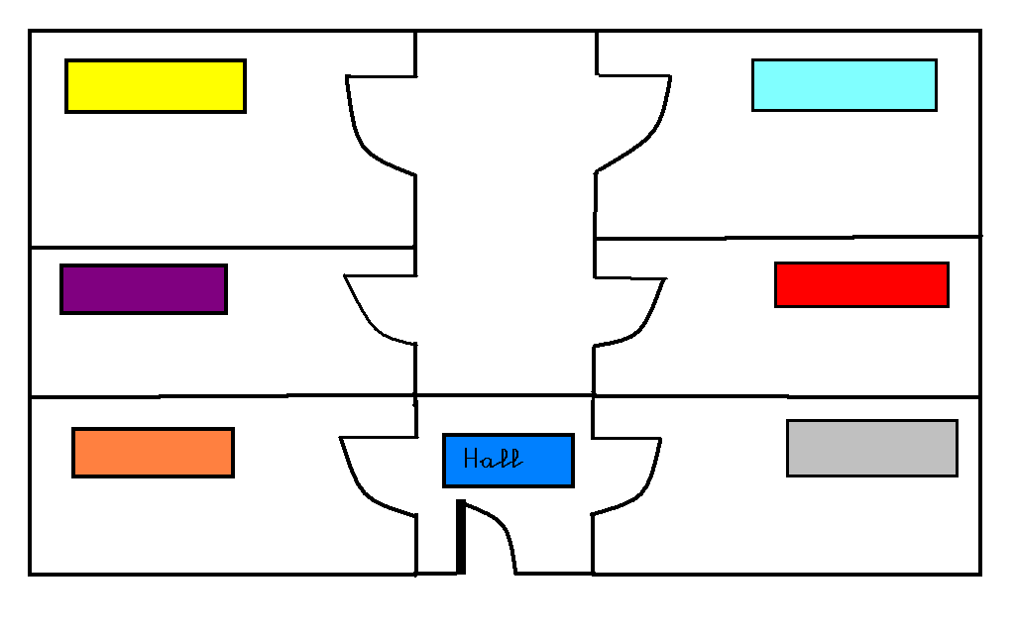

Development:
Students have to read the story that appears in this video: http://photopeach.com/album/16shtaq
First, they have to watch the video, the pictures with the text. Then, they have to watch it for the second time, and they have to read it carefully.
Then they have to answer the following questions.
- Choose the best title:
  - My house is alive.
  - The haunted house.
  - The little mouse
  - Sarah and her family

- Where is Sarah’s sandwich?
- In the Kitchen.
- In the living room.
- In the fridge.
- In the bathroom

3. What is the place where Sarah brushes her teeth?
- In the dining room.
- In the bathroom.
- In the hall.
- In the kitchen.

- When Sarah is in the living room the TV is…
- Off.
- There is no TV.
- On.
- On the sofa

- What is the place where Sara’s sleep?
- The living room.
- The bedroom.
- The dining room.
- The bathroom.

- Where are Sarah’s parents?
- Sleeping.
- Walking Tobby.
- Cooking.
- Watching TV.

- Is Sarah’s house alive??
- Yes, there are many ghosts.
- No, it isn’t alive. It’s a domotic house.
- Yes, the house is a magic house.
- Yes, there is an UFO.

- What happens in the hall??
- Sarah discovers a ghost.
- The light is on.
- There is a mouse playing with the remote control of Sarah’s house.
- Tobby is there.

Then, they can watch the video again to check the answers.

Acting story
The children have to acting the story with a playhouse and a doll (Sarah).
- Sarah: Hello! I’m Sarah. I’m ten years old. I’m in forth of Primary and my family and I live in this new house. And I will tell you something… ssshhhh! This house is different. This house is strange.
- Parents: Sarah, darling, we are going to walk Tobby. You have your dinner in the kitchen. Remember that your sandwich is into the fridge. We will come back in an hour. If you want something phone us!
Sarah: OK daddy! OK mummy! See you!
Tobby: Woof! Woof!
- Song: I’m going to the KITCHEN, KITCHEN, KITCHEN, I’m going to the KITCHEN, right now.
- Sarah: I’m hungry! Where is my sandwich? Aaaaaaaaaaaaaah!!!! It is into the fridge!
- Sarah: Oh my god! The light! The light is off! – What happens?
- Song: I’m going to the DINING ROOM, DINING ROOM, DINING ROOM, I’m going to the DINING ROOM, right now.
- Sarah: Mmmmmmmmmh!! Delicious! Music?! Music is playing! Daddy? Mummy? Are you there? Mmmmmmmh, oh no... Is there any ghost in my house?
- Song: I’m going to the BATHROOM, BATHROOM, BATHROOM, I’m going to the BATHROOM, right now.
- Sarah: I’m brushing my teeth. I love brushing my teeth! GLU GLU GLU GLU. (Oh my god! The shower! The shower is turned on! Is there any ghost in my house?
- Song: I’m going to the BEDROOM, BEDROOM, BEDROOM, I’m going to the BEDROOM right now.
- Sarah: Oh no! I’m so afraid… I’m going to sleep but before… I’m going to close the window.
- Sarah: Oh my god! The sprinklers! The sprinklers are turned on in the GARDEN! What happens? WHAT HAPPENS? Is there any ghost in my house?
- Song: I’m going to the LIVING ROOM, LIVING ROOM, LIVING ROOM, I’m going to the LIVING ROOM right now.
- Sarah: Oh my god! The television! The television is turned on! I’m going to phone my parents!!! I’m very frightened! My house is alive!!
- GSGSGSGSGSGS
- Sarah: What happens in the hall? What is that noise?
- Song: I’m going to the HALL, HALL,HALL, I’m going to the HALL, right now.
- GSGSGSGSGSGSG
- Sarah: Oh! That’s it! Uuuuuf! It is only a mouse! There isn’t any ghost! … This little mouse is playing with the remote control of my house!
- Sarah: Now, I know why my house is different. I live in a domotic house!

Development:
http://photopeach.com/album/16shtaq
First, they have to watch the video that we have worked in another session. Then, they have to watch it for the second time, and they have to read it carefully.
Then they have to answer the following questions.
1. Where is Sarah’s sandwich?
In the Kitchen.
In the living room.
In the fridge.

2. What is the place where Sarah brushes her teeth?
In the dining room.
In the bathroom.
In the hall.
3. When Sarah is in the living room the TV is…
Off.
There is no TV.
On.
4. What is the place where Sara’s sleep?
The living room.
The bedroom.
The dining room.
5. Where are Sarah’s parents?
Sleeping.
Walking Tobby.
Cooking.
6. Is Sarah’s house alive??
Yes, there are many ghosts.
No, it isn’t alive. It’s a domotic house.
Yes, the house is a magic house.
7. What happens in the hall??
Sarah discovers a ghost.
The light is on.
There is a mouse playing with the remote control of Sarah’s house.

Then, they can watch the video again to check the answers.

