**THE WRITING PROCESS**

**DEMANDS OF THE SPANISH EDUCATIONAL FRAMEWORK**

**Produce short ,simple written texts in the foreign language in real or simulated communication situations , familiar to the children , following the formal conventions of written language**

**TOWARDS A METHODOLOGY FOR THE TEACHING OF WRITING**

**A series of stages have been stablished where the activities become increasingly more complex ,creating an integrated process with an objective, to express oneself writing in English.**

**1st STAGE: FAMILIARISATION: writing words, simple grammatical phrases , activities involving copying , tracing and focused mainly on spelling and vocabulary.**

**SOME EXAMPLES:**

****

**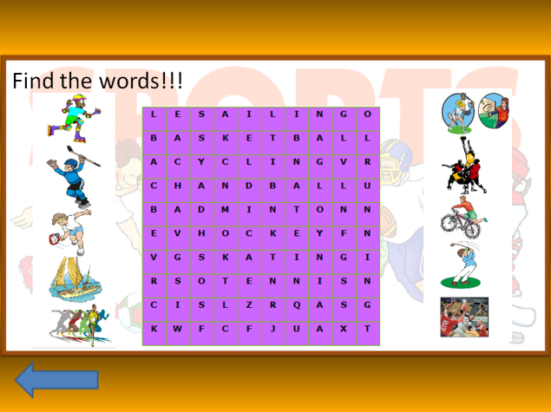**

ACTIVITY : write :I have got / I haven’t got

****

I \_\_\_\_\_\_\_\_\_\_\_\_\_\_\_\_\_\_\_\_\_\_\_water.

I \_\_\_\_\_\_\_\_\_\_\_\_\_\_\_\_\_\_\_\_\_\_\_a biscuit.

I \_\_\_\_\_\_\_\_\_\_\_\_\_\_\_\_\_\_\_\_\_\_\_milk.

I \_\_\_\_\_\_\_\_\_\_\_\_\_\_\_\_\_\_\_\_\_\_\_juice.

I \_\_\_\_\_\_\_\_\_\_\_\_\_\_\_\_\_\_\_\_\_\_\_a sandwich.

I \_\_\_\_\_\_\_\_\_\_\_\_\_\_\_\_\_\_\_\_\_\_\_bacon

I \_\_\_\_\_\_\_\_\_\_\_\_\_\_\_\_\_\_\_\_\_\_\_lettuce.

I\_\_\_\_\_\_\_\_\_\_\_\_\_\_\_\_\_\_\_\_\_\_\_ an ice cream

**2nd STAGE : CONTROLLED AND GUIDED WRITING**

**The teacher offers the pupil linguistic material to be used following precise guidelines, but controlling the pupil´s production to reduce mistakes .**

**The teachers give the pupils some models first.**

* READ AND WRITE

Oh! Look at these animals!

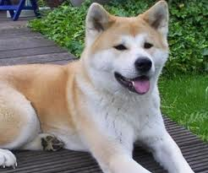

My name is Doggy. I’m a dog.

I love food: meat , meat and meat!

I don’t like fish and I don’t like fruit.

My favourite drink is water!

And sometimes, I like cats too!

**1. Writing**

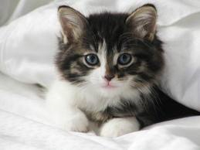My name is \_\_\_\_\_\_\_\_\_\_\_\_\_\_\_\_\_\_\_\_\_

I love \_\_\_\_\_\_\_\_\_\_\_\_\_\_\_\_\_\_\_\_\_\_\_\_\_\_

I don’t like \_\_\_\_\_\_\_\_\_\_\_\_\_\_\_\_\_\_\_\_\_\_

My favourite drink \_\_\_\_\_\_\_\_\_\_\_\_\_\_\_\_!

And sometimes, I like \_\_\_\_\_\_\_\_\_\_ too!

3rd STAGE: FREE WRITING

The students write freely on any topic .The free writing is used with higher level students .The emphasis is on quantity rather than on quality.

Getting ideas down on paper is considered to be the priority.....With time, errors in grammar and syntax will gradually be corrected with the teacher´s help.

SOME EXAMPLES

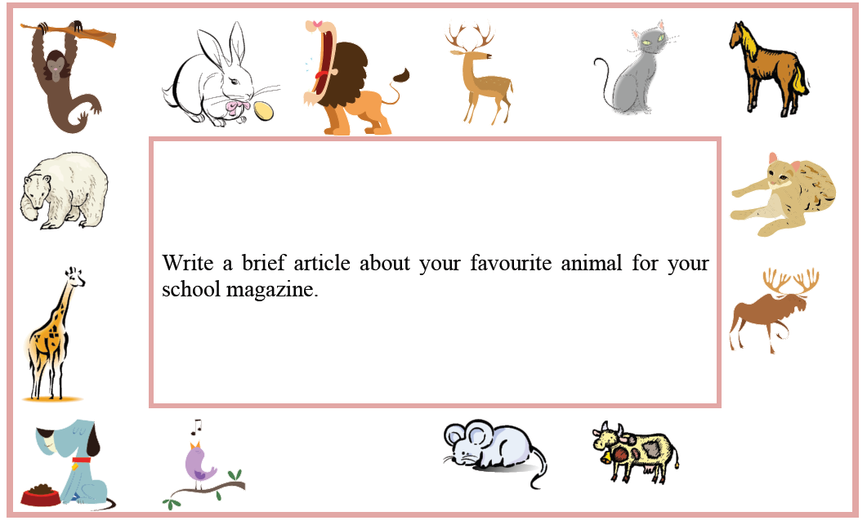

ACTIVITY: Write how to prepare a fruit salad

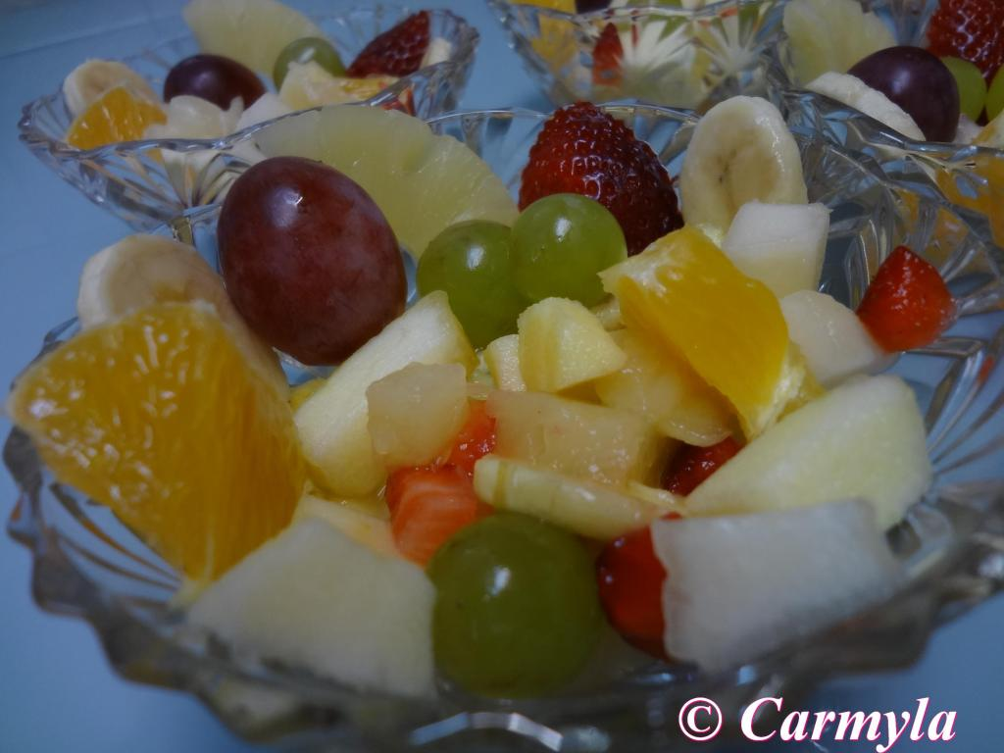

(You can use verbs like take, cut and peel)

\_\_\_\_\_\_\_\_\_\_\_\_\_\_\_\_\_\_\_\_\_\_\_\_\_\_\_\_\_\_\_\_\_\_\_\_\_\_\_\_\_\_\_\_\_\_\_\_\_\_\_\_\_\_\_\_\_\_\_\_\_\_\_\_\_\_\_\_\_\_\_\_\_\_\_\_\_\_\_\_\_\_\_\_\_\_\_\_\_\_\_\_\_\_\_\_\_\_\_\_\_\_\_\_\_\_\_\_\_\_\_\_\_\_\_\_\_\_\_\_\_\_\_\_\_\_\_\_\_\_\_\_\_\_\_\_\_\_\_\_\_\_\_\_\_\_\_\_\_\_\_\_\_\_\_\_\_\_\_\_\_\_\_\_\_\_\_\_\_\_\_\_\_\_\_\_\_\_\_\_\_\_\_\_\_\_\_\_\_\_\_\_\_\_\_\_\_\_\_\_\_\_\_\_\_\_\_\_\_\_\_\_\_\_\_\_\_\_\_\_\_\_\_\_\_\_\_\_\_\_\_\_\_\_\_\_\_\_\_\_\_\_\_\_\_\_\_\_\_\_\_\_\_\_\_\_\_\_\_\_\_\_\_\_\_\_\_\_\_\_\_\_\_\_\_\_\_\_\_\_\_\_\_\_\_\_\_\_\_\_\_\_\_\_\_\_\_\_\_\_\_\_\_\_\_\_\_\_\_\_\_\_\_\_\_\_\_\_\_\_\_\_\_\_\_\_\_\_\_\_\_\_\_\_\_\_\_\_\_\_\_\_\_\_\_\_\_\_\_\_\_\_\_\_\_\_\_\_\_\_\_\_\_\_\_\_\_\_\_\_\_\_\_\_\_\_\_\_\_\_\_\_\_\_\_\_\_\_\_\_\_\_\_\_\_\_\_\_\_\_\_\_\_\_\_\_\_\_\_\_\_\_\_\_\_\_\_\_\_\_\_\_\_\_\_\_\_\_\_\_\_\_\_\_\_\_\_\_\_\_\_\_\_\_\_\_\_\_\_\_\_\_\_\_\_\_\_\_\_\_\_\_\_\_\_\_\_\_\_\_\_\_\_\_\_\_\_\_\_\_\_\_\_\_\_\_\_\_\_\_\_\_\_\_\_

TEACHING WRITING TO PUPILS USING SOME APPLICATIONS:

WE WORK writing WITH PHOTOPEACH

<http://photopeach.com/album/16shtaq>

Read the story and answer the questions:

**1. Where is Sarah’s sandwich?**

**2. What is the room where Sarah brushes her teeth?**

**3. When Sarah is in the living room the TV is…**

WE WORK writing WITH VOKI

Listen and write the answers to the questions.

* [**http://www.voki.com/pickup.php?scid=7031375&height=400&width=300**](http://www.voki.com/pickup.php?scid=7031375&height=400&width=300)

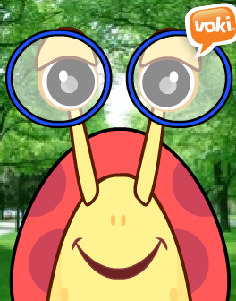

**Hello! My name is Lulu.**

**Listen and write:**

**how many rooms are there in your house?**

WE WORK writing WITH GLOSTER

ACTIVITY:Watch the video and match the pictures to the words

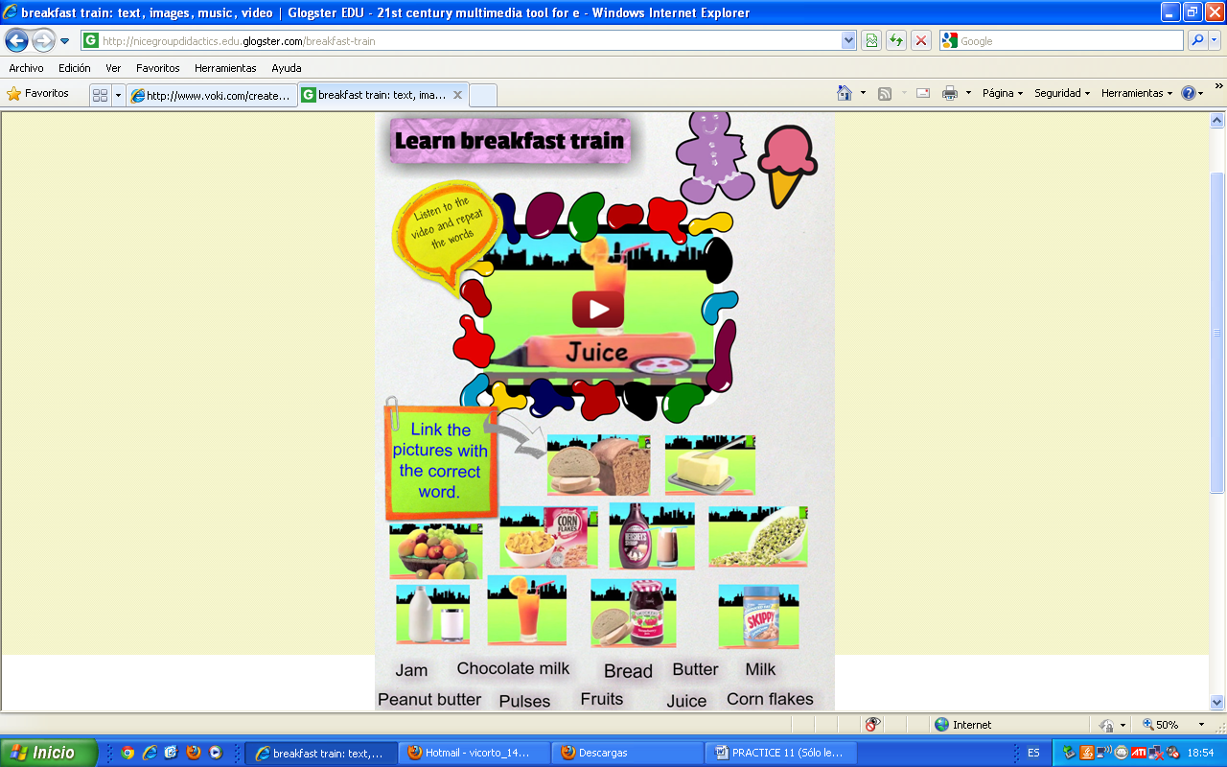

.

**WE WORK WITH PIXTON .**

[**http://www.pixton.com/es/schools/group/147892/edit/project/286202#tab-3**](http://www.pixton.com/es/schools/group/147892/edit/project/286202#tab-3)

* Read the comic and answer the questions.

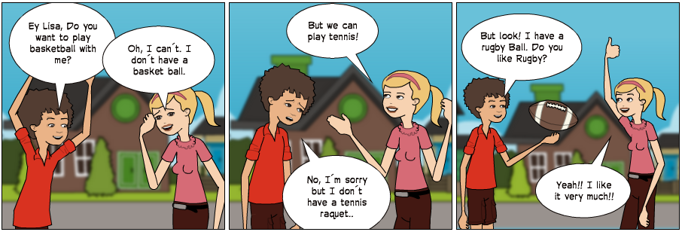

* What sports do they want to play?
* Does Lisa have a basket ball?
* What type of ball do they have?
* At the end, what sport are they going to play?

THE STUDENTS LEARN TO WRITE USING GRAPHIC ORGANIZERS

ACTIVITY : Listen to the story and afterwards ,write a brief summary of the story.

**the summary of the story**

|  |  |  |
| --- | --- | --- |
| **How does the story begin?** | **What happens in the story?** | **What happens at the end?** |
|  |  |  |

**COMMUNICATIVE APPROACH**

The purpose and addressee of a piece of writing are the focal points of this approach.

When a student writes something to someone, the writing task is a truly communicative exercise.

A student can write a text destined to another student in the class who will respond in some way.

ACTIVITY:Read the email from your English friend, David.

|  |  |
| --- | --- |
| **From:** | **David** |
| **To:** |  |
| **It was great you came to my house last Sunday. We really enjoyed playing Wii Sports. Can you come again next Saturday to watch a DVD? Which DVD do you want to watch? Or do you prefer playing computer games? If you are coming, what time can you come? See you later.**  **David** | |

*Write an email to David . Write the email on your answer sheet.*

|  |
| --- |
| ACTIVITY : write Santa a letter |
| <http://www.santaclauslive.com/main.php?link=kirjoita_joulupukille&pid=2&kieli=eng>  santaletter_sb_en.jpg  web_01.gif |
|  |
|  |

TODAS ESTAS ACTIVIDADES HAN SIDO CREADAS POR LOS ALUMNOS DE DIDÁCTICA 2012 para sus unidades didácticas.

WRITING

Our children can write their own comments about different topics

<http://learnenglishkids.britishcouncil.org/en/your-turn/cooking>

And they can write their own stories using this page :

storyjumper