UNIT OF WORK
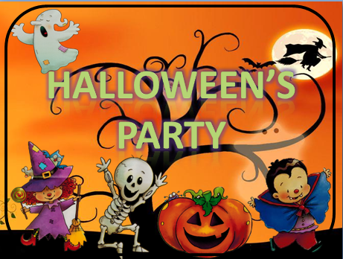

(Group 5. Early Childhood education)
1.- Curricular references.
We are going to include three sections. In the first one will be compiled objectives, evaluation
criteria and competences. In the second section will be included the didactic objectives to develop in the unit of work. The last section will include the block of contents that will be worked.

1.1.- 1.1. Area’s objectives, evaluation criteria and competences for this
unit of work taking into account the ones reflected in the Didactic
Programming
Next, we show objectives, evaluation criteria and competences that we have related to our
Didactic Programming. Doing this, we will be able to have access to the information of the Didactic
Programming in order to design the development of the unit of work in an integrate way.
Area’s objectives | Evaluation criteria | Competences
Objective 1. To use the oral  language to express feelings,  wishes and ideas. To value  their use as a vehicle to  interact with others and as a  way to regular the  coexistence. All of this in the  owner and foreign language.  Objective 2. To understand  messages and intentions of  children and adults showing a  positive attitude in the owner  and foreign language.  Objective 4. To understand  and to enjoy listening,  interpreting and reading  literally texts with an  attention attitude.  Objective 5. To understand  and to represent ideas and  feelings using plastic, corporal  and musical language through  different techniques. To show  attention in the knowledge of  artistic works which are  expressed in these languages. | Criterion 1. To use the own  and foreign oral language to  interact with their parents  and adults and to participate  in conversations.  Criterion 2. To understand  different oral messages  showing an active and  respectful attitude of listening  and communication.  Criterion 3. To enjoy listening  and reading literally texts.  Criterion 4. To express and to  communicate using materials  and techniques of artistic and  audiovisual language showing  attention.  Criterion 5. To use the computer to express and communicate | Communicative language  competence.  Competence in the  knowledge and  interaction with the  world.  Social and civic  Competence.  Cultural and artistic  Competence.  Autonomy and personal  initiative competence.  Emotional competence.  Learning to learn competence.  Digital and information processing competence.

1.2.- Didactic objectives of the unit of work

Didactic objectives
1. Use oral language to express vocabulary about Halloween in order to have a good communication and relation with others.
2. Get to understand the messages about Halloween with a positive attitude towards language.
3. Start and get used the social value of reading and writing as a means of communicating and enjoying with the characteristics of Halloween.
4. Start to enjoy listening and reading the story “Pumpkin is afraid”
5. Understand and enjoy “Pumpkin is afraid” and games by using body language, music and new technologies.
6. Use the computer to listen and make oral interaction in different digital programs to improve their knowledge about Halloween.

1.3.- Block of contents worked in the unit of work

Block of contents
Block 1. Oral language.
Block 2. Creative languages.
Block 3. The information and communication technologies language

2. LEARNED ELEMENTS. INDICATORS TO EVALUATE THE UNIT OF WORK

Next we have the indicators that will be our reference to work and to evaluate the unit of
work. The unit of work should be designed in order to be able to evaluate each student and the
indicators that he or she has passed and the ones that hasn’t pass.

At the end of the unit each pupil should be competent in:

- Indicator C1.1.To use the foreign language to interact with adults (LAN, S&C, A&PI, EC).

- Indicator C1.2.To use the foreign language to participate in conversations with adults and peers (LAN, S&C, A&PI, EC).

- Indicator C2.1.To understand oral messages (LAN, EC).

- Indicator C2.2.To show an active and respectful attitude of listening and communication (KIW, S&C, EC).

- Indicator C3.1. To enjoy listening literally texts (LAN, C&A, EC).

- Indicator C3.2. To enjoy reading literally texts (LAN, C&A, EC).

- Indicator C4.1. To communicate throw different materials and techniques (LAN, C&A,
EC).

-Indicator C4.19. To sing songs
-Indicator C5.13. To play games
3.- NUMBER OF SESSIONS AND THEIR DEVELOPMENT
This unit of work will be developed in twelve sessions. The sessions are organized in the following
way:
Initial stage | Development stage | Summary stage | Generalization stage
1 | 8 | 2 | 1

3.1. Initial stage

Sesión 1

HELLO ROUTINE
SPEAKING
Timing: 5 minutes | Materials: flashcard about feelings. | Grouping: All the class
Development: To start the session children sit on the floor in a circle or semicircle in front of the teacher and sing the song.

HELLO SONG: Hello, hello, how are you today?
I´m happy, happy, happy
Hello, hello, how are you today?
I´m sad, sad, sad.
Hello, hello, how are you today?
I´m hungry, hungry,
I´m hungry today.
Ñam, ñam, ñam, ñam, ñam.

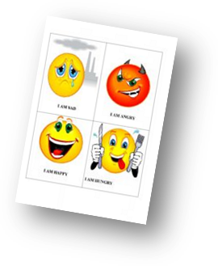
In the first session we are going to introduce our topic, which is Halloween.

First of all we are going to do a brainstorming, children have to say what they know about halloween and what they want to learn.

We need to ask children about what they know about Halloween.

Also, we need to introduce our characters: a witch, a pumpkin, a skeleton, a monster, a vampire.

We are going to sing hello and goodbye song.
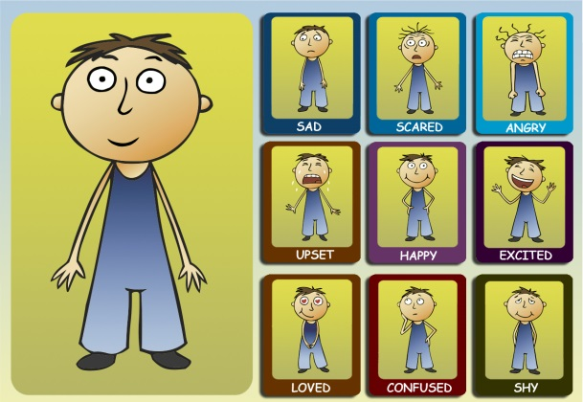

GOODBYE ROUTINE
SPEAKING
Timing 5 minutes | Materials: | Grouping: All the class
Development: To finish the session children sit on the floor in a circle or semicircle in front of the teacher and sing the song.

GOODBYE SONG: Good bye, good bye, see you again
Good bye, good bye see you my friends.
God bye, good bye I have fun today,
I have fun today.
Bye, bye.

*We will sing the hello song and the goodbye song to start and finish each session.

3.2. Development Stage

Sesión 2

Activity 1 STORY: “PUMPKIN IS AFRAID”
LISTENING
Timing: 10 minutes | Materials: puppets. | Grouping: All the class
Development: Children sit on the floor in a circle or semicircle in front of the teacher and teacher tell them the story.

Pumpkin is afraid
Once upon a time in a Halloween’s night one group of children are in a party.
He is Tommy and he has a pumpkin with candies.
Tommy: Hello friend! I am here, this is my pumpkin. Look!!! He has a lot of candies in his head.
Friends: Wooow wooow candies!!!
Ghost: Uuuuuhhh! A candy please uuuuhhhh
Pumpkin: No.
Tommy I am afraid.
Tommy: Afraid? Why? He is our friend, he is a ghost.
Ghost: Yes, I am a ghost uuhh.
Witch: Jijijiji a candy please jijijiji
Pumpkin: No.
Tommy I am afraid
Tommy: Afraid? Why? He is our friend, he is a witch.
Witch: Yes, I am a witch jijijii
Monster: jo jo jo a candy please jjojoj
Pumpkin: No.
Tommy I am afraid.
Tommy: Afraid? Why? He is our friend, he is a monster.
Monster: Yes, I am a monster jojojo
Skeleton: ahh a candy please ahh
Pumpkin: No.
Tommy I am afraid.
Tommy: Afraid? Why? He is our friend, he is a skeleton.
Skeleton: Yes, I am a skeleton ahh
Tommy: Pumpkin you have all the candies in your head.
Pumpkin: I know but I am afraid.
Tommy: They are our friends.
Friends, come here and show your face to pumpkin.
Pumpkin: Ahh! They are friends.
“I am not afraid I am not afraid” (SONG)
Candies for everyone!
Friends: (go to take candies)
Pumpkin: (and the pumpkin gives candies to the children)

Activity 2: “PUT IT IN ORDER”
READING
Timing 10 minutes | Materials: flashcards with the pictures of the story | Grouping: groups of six.
Development: Children are in groups of six, each child has a flashcard with a character of the story, and they must to put them in the same order that they appear in the story. When they are in the correct order they need to put up the flashcard and say aloud the name of each character to the rest of the class.
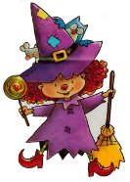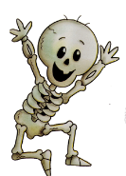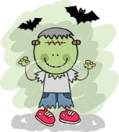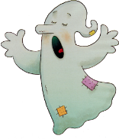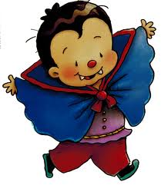

ACTIVITY 3: “AND YOU?”
ORAL INTERACTION
Timing: 10 minutes | Materials: - | Grouping: All the class
Development: Children make a circle and they have to say his/her name and how they feel, then they ask to his/her classmate:

- Hello, hello my name is Sofia and I am happy, and you?

- 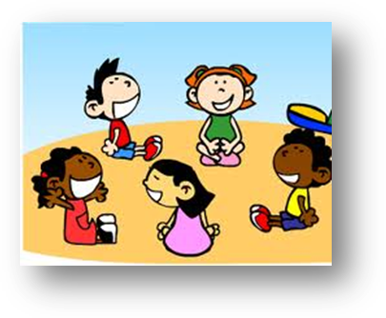Hello, hello my name is John and I am sad, and you?

Activity 4: “LOOK FOR THE SAME PICTURE”.
WRITING
Timing 5 minutes | Materials: the copy | Grouping: individual
Development: We give to children a copy with Halloween pictures, children have to lock at the first Halloween picture in each row. Then they have to circle the picture that is the same as the first one in each row.
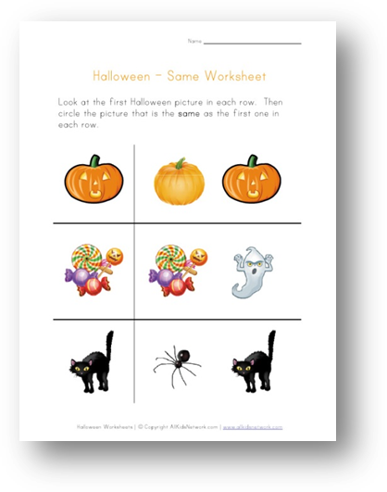

Sesión 3

Activity 1: Halloween´s song
LISTENING AND SPEAKING
Timing: 10 minutes | Materials: Cd song | Grouping: All the class
Development: children need to listen and sing “Trick or Treat” song.
Knock knock, trick or treat?
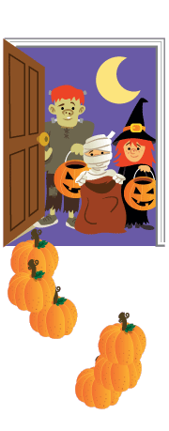 Who are you?
I'm a ghost. I'm a little ghost.

Knock knock, trick or treat?
Who are you?
I'm a witch. I'm a little witch

Knock knock, trick or treat?
Who are you?
I'm a skeleton. I'm a little skeleton

Knock knock, trick or treat?
Who are you?
I'm a monster. I'm a little monster.

Knock knock, trick or treat?
Who are you?
I'm a pumpkin. I'm a little pumpkin.

Activity 2 “SHOW ME YOUR PICTURE”.
SPEAKING
Timing 10 minutes | Materials: Flashcard the halloween´s characters. | Grouping: individual
Development: We have to show the flashcards with halloween´s characters and at the same time we have to say in a loud way the name of this character. Then we give to students some flashcard with halloween´s characters and when we say the name of one character the child who has this character has to stand up, show the flashcard and say the name of this character.
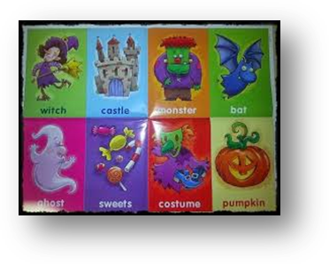

Activity 3: “ DOMINO”
READING
Timing 10 minutes | Materials: domino | Grouping: pairs.
Development: They have to join the pictures that are similar.

Activity 4: “LOOK: “A COMIC”
READING

Timing 5 minutes | Materials: PC, PIXTON progamme. | Grouping: All the group
Development: Children sit on the floor in a circle or semicircle in front of the PC and teacher tell them the comic.

http://www.pixton.com/es/comic/por834od

Sesión 4

Activity 1 STORY:” PUMPKIN IS AFRAID”
LISTENING
Timing: 10minutes | Materials: digital board with story. | Grouping: All the class
Development: Children need to listen to the story at the same time that they are looking the pictures of the story in the digital board.
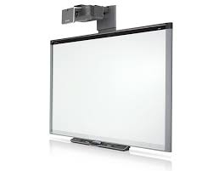

Activity 2: “ MAKE GESTURES”
LISTENING
Timing: 10 minutes | Materials: flashcards. | Grouping: two group of 12
Development: In this activity children have to listen to the teacher says and then they have to represent the word that teacher said making gestures.
First of all teacher show to the children the gesture that represent each pictures.
Pumpkin: open the arms, lifting your elbows.
Ghost: arms up and move then like a ghost saying at the same time uhhhhhh.
Vampire: show your teeth.
Monster: show nails and say ahhhhhhggggg.
Mommy: arms up and move them like a mommy very slowly.

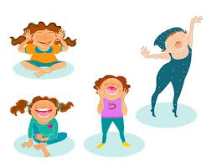

Activity 3: ”FOLLOW THE SERIES OF IMAGES”
WRITING
Timing 15 minutes | Materials: a copy with the series and the missing pictures. | Grouping: individual
Development: we give to children a copy with different series of pictures and below of them we have the missing pictures that children have to cut and paste it in the correct order to follow the series. First of all, they have to color the different pictures.
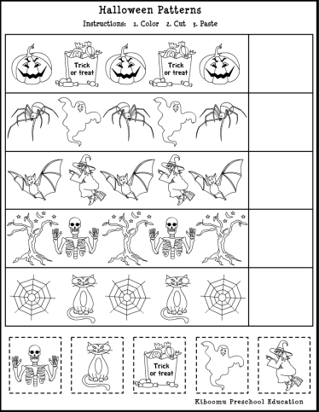

Activity 4: “PC GAMES”
ITC
Timing 5 minutes | Materials :PC | Grouping: individual or in pairs.
Development: This activity is designed as an extra word for children who finish early making the activity before.
Link:
http://www.gamesgames.com/game/Halloween-Costume-Dress-Up.html

Development: Children have to dress up the different characters with the clothes.

Sesión 5

Activity1 : CHANT “WHO TOOK THE CANDY?”
ORAL INTERACTION
Timing 10 minutes | Materials: flashcard and the pumpkin | Grouping: All the group
Development: we give to children the pumpkin a flashcard and they have to make a circle. They have to pass the pumpkin to the child on the right singing the chant, and when the song end the child that has the pumpkin the other children say the name and the character and “has the candy”. If the child doesn’t have the candy we continue with the song.
Who took the candy from the pumpkin’s head?
Who took the cookie from the pumpkin’s head?
Gema ghost has the candy.
No!

Activity 2 “HOW ARE YOU”
LISTENING
Timing: 10 minutes | Materials: PC, copys. | Grouping: All the class
Development: First teacher give to the children one copy with a Halloween pictures related with the vocabulary, for example a ghost, witch, pumpkin, monster, etc. but this pictures there aren´t a face, because children have to discover how is this picture but first they have to listen to the voki and choose the best answer, something like this:
Voki says: hello I am a happy gost. And then children have to draw a happy or sad face in each picture.

http://www.voki.com/php/viewmessage/?chsm=4f4a1d9c5eec72a6f43bb68328b189d4&mId=2046539

http://www.voki.com/php/viewmessage/?chsm=61c8df072c45f05b82c14536b618092f&mId=2046552

http://www.voki.com/php/viewmessage/?chsm=cefc4671b5eed3ec748e3a00aa7758fc&mId=2046566

http://www.voki.com/php/viewmessage/?chsm=137b68b3ccdf8f1ff2155c41d0227f53&mId=2046681

Activity 3: “THE WRITTEN WORDS”
WRITING
Timing 10 minutes | Materials: a copy with the picture and the names. | Grouping: individual
Development: we give to children a copy with the pictures of Halloween and below the names of the pictures. Children have to write the name of the picture following the patterns that he can found in the lines and after this they have to color the picture.
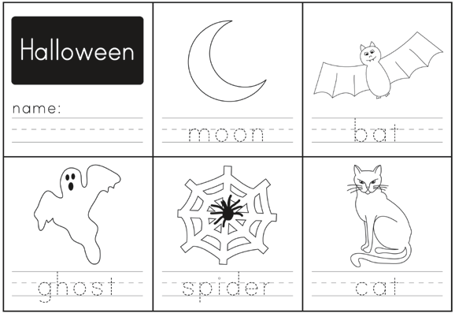

Activity 4: “PC GAMES”
WRITING
Timing 5 minutes | Materials :PC | Grouping: individual or in pairs.
Development: This activity is designed as an extra word for children who finish early to make the activity before.
Link:
http://www.gamesgames.com/game/Cute-Pumpkin-Head.html

Development: Children have to make a pumpkin moving the mouse in the right direction. They have to choose the different parts of the pumpkin’s face.

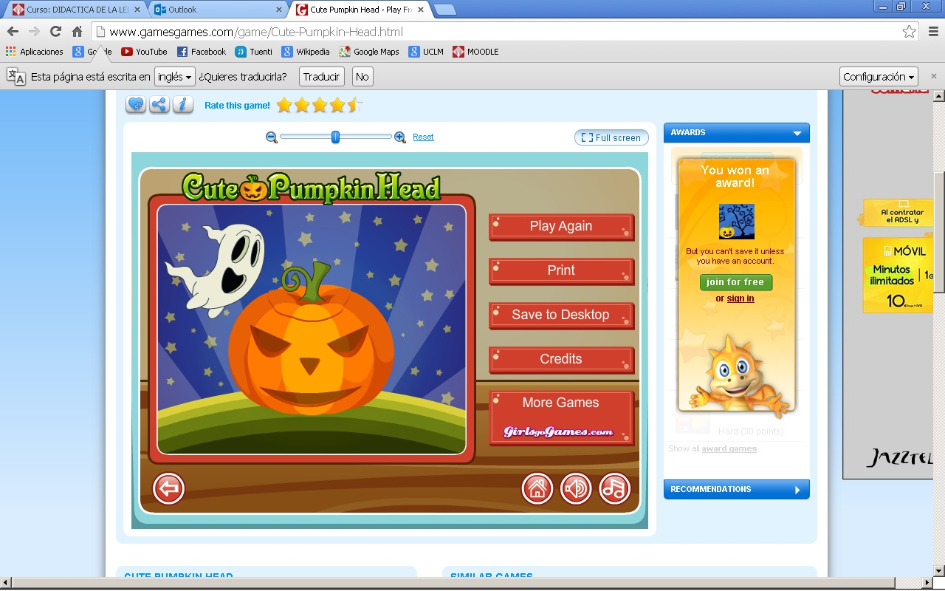

Sesión 6

Activity 1: “COMPLEMENTARY ACTIVITY”
LISTENING, ORAL INTERACTION, READING, WRITING.
Timing 45 minutes | Materials: | Grouping: all the class.
Development: The complementary activity for our unit of work consists in going to the theatre and to see a representation of Halloween. The representation of Halloween is like our story telling, because the characters are going to be similar to our characters. The actors of the theatre are going to use the same vocabulary that we use in our class, and children can recognize the vocabulary and follow the story.

After it, in the classroom children need to do some activities about this theatre:
- They have to recognize some characters of the story with flashcards. We put the flashcards in the floor, and they have to put down the flashcards that are not in the theatre.
- We give them some pictures about the story, and they have to put the pictures in the correct order that happen in the theatre.
- After that, children have to draw a picture of his/her favourite character of the theatre.
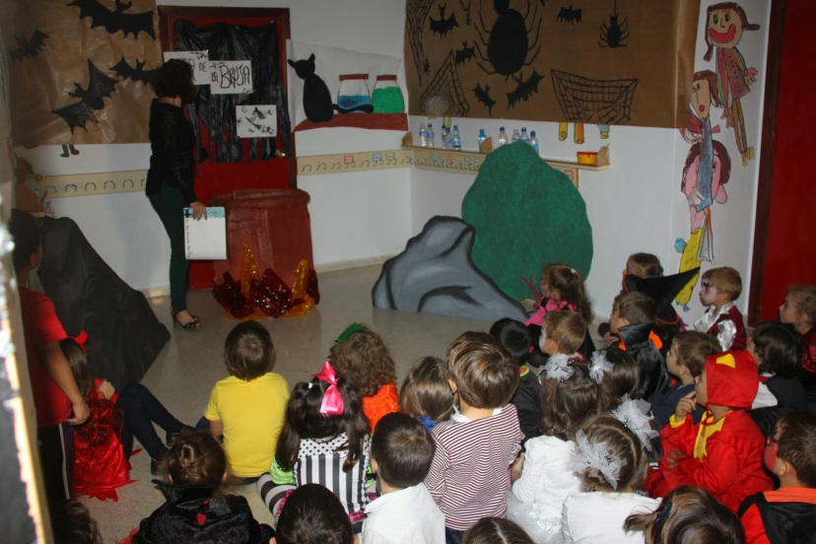

Sesión 7

Activity 1: HALLOWEEN´S SONG

LISTENING AND SPEAKING
Timing: 10 minutes | Materials: Cd song | Grouping: All the class
Development: Children have to listen and sing “Trick or Treat” song making gestures about Halloween characters.
Knock knock, trick or treat?
Who are you?
I'm a ghost. I'm a little ghost.

Knock knock, trick or treat?
Who are you?
I'm a witch. I'm a little witch

Knock knock, trick or treat?
Who are you?
I'm a skeleton. I'm a little skeleton

Knock knock, trick or treat?
Who are you?
I'm a monster. I'm a little monster.

Knock knock, trick or treat?
Who are you?
I'm a pumpkin. I'm a little pumpkin.

Activity 2: “WHAT´S MISSING”
READING and SPEAKING
Timing: 5 minutes | Materials: flashcard and blackboard | Grouping: all the group
Development: We put flashcards with pictures about halloween the blackboard, and then we give to children some miniflashcards with the same numbers. We say to children that they need to close his eyes and we take away one picture. When children open his eyes they have to show the miniflashcard that is missing on the blackboard.
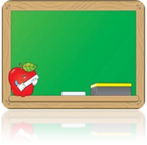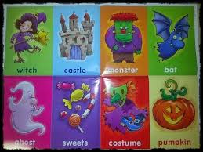

Activity 3: “HALLOWEEN STICKERS”
LISTENING AND WRITING
Timing 5 minutes | Materials: table with the pictures. | Grouping: individual
Development: we give to children one table with the table and pictures of Halloween characters. We say a number and a character and children have to put a sticker where they find the character that we say.
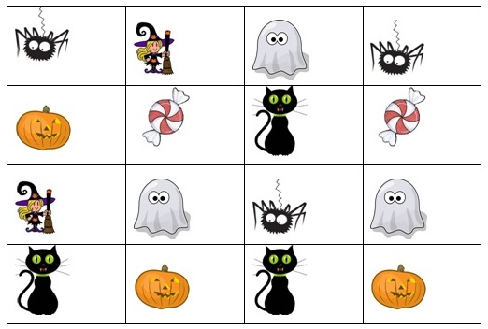

ACTIVITY 4: “TWINS”
ORAL INTERACTION
Timing: 15 minutes | Materials: Flashcards with the Halloween’s characters. | Grouping: All the class
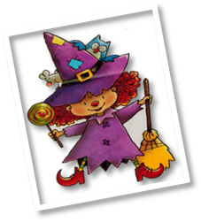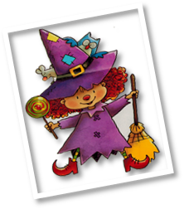Development: Children make two lines and then we give to them different characters of our story. One child of one line say his number and the child who has the same number in the other line stand up and go with his couple.

Sesión 8

Activity1 : CHANT “WHO TOOK THE CANDY?”
ORAL INTERACTION
Timing 10 minutes | Materials: flashcard and the pumpkin | Grouping: All the group
Development: we give to children the pumpkin a flashcard and they have to make a circle. They have to pass the pumpkin to the child on the right singing the chant, and when the song end the child that has the pumpkin the other children say the name and the character and “has the candy”. If the child doesn’t have the candy we continue with the song.
Who took the candy from the pumpkin’s head?
Who took the cookie from the pumpkin’s head?
Gema ghost has the candy.
No!

Activity 2 “BINGO”
LISTENING
Timing: 10 minutes | Materials: flashcards with pictures of the characters and copys. | Grouping: All the class
Development: First teacher give to the children one copy with a Halloween bingo related with the vocabulary, for example a ghost, witch, pumpkin, monster, etc.
Teacher says the Halloween vocabulary in order and children who have this picture have to make a cross or put a sticker inside and the winner will be the child who has a cross or a sticker in each picture.

Activity 3: “MATCH PAIRS”
READING
Timing 1 0 minutes | Materials: flashcards | Grouping: in pairs
Development: children are in pairs and they have flashcards that are backwards. There are two flashcard with the same picture and children need to found these pictures and made pairs. They have to say the name of the character that they take to their partner.

Activity 4: “COLOUR THE PUMPKIN”
READING AND WRITING
Timing 5 minutes | Materials: copy and different crayons. | Grouping: individual
Development: Children must color the picture with the correct colours, every colour has a number.
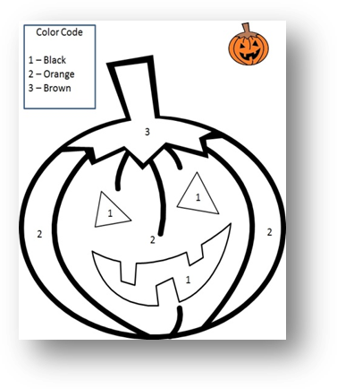

Sesión 9
Activity 1 Story: “Pumpkin is afraid”
LISTENING
Timing: 10 minutes | Materials: Story book. | Grouping: All the class
Development: Children sit on the floor in a circle or semicircle in front of the teacher and teacher tell them the story, they can participate making gestures about the characters of the story.

Pumpkin is afraid
Once upon a time in a Halloween’s night one group of children are in a party.
He is Tommy and he has a pumpkin with candies.
Tommy: Hello friend! I am here, this is my pumpkin. Look!!! He has a lot of candies in his head.
Friends: Wooow wooow candies!!!
Ghost: Uuuuuhhh! A candy please uuuuhhhh
Pumpkin: No.
Tommy I am afraid.
Tommy: Afraid? Why? He is our friend, he is a ghost.
Ghost: Yes, I am a ghost uuhh.
Witch: Jijijiji a candy please jijijiji
Pumpkin: No.
Tommy I am afraid
Tommy: Afraid? Why? He is our friend, he is a witch.
Witch: Yes, I am a witch jijijii
Monster: jo jo jo a candy please jjojoj
Pumpkin: No.
Tommy I am afraid.
Tommy: Afraid? Why? He is our friend, he is a monster.
Monster: Yes, I am a monster jojojo
Skeleton: ahh a candy please ahh
Pumpkin: No.
Tommy I am afraid.
Tommy: Afraid? Why? He is our friend, he is a skeleton.
Skeleton: Yes, I am a skeleton ahh
Tommy: Pumpkin you have all the candies in your head.
Pumpkin: I know but I am afraid.
Tommy: They are our friends.
Friends, come here and show your face to pumpkin.
Pumpkin: Ahh! They are friends.
“I am not afraid I am not afraid” (SONG)
Candies for everyone!
Friends: (go to take candies)
Pumpkin: (and the pumpkin gives candies to the children)

Activity 2 “DICTATION”
LISTENING
Timing: 10 minutes | Materials: Copy and stikers with numbers. | Grouping: individual
Development: In this activity we give to the children one copy about the activity and some stickers with numbers.
In this piece of paper there are some pictures about Halloween related to the vocabulary.
Teacher told them some words about this vocabulary and they have to put a sticker in each picture in the same order that the teacher said. For example, teacher says: number one: ghost; and they have to stick the one´s sticker in the ghost.
Number two: witch; and they have to stick the two´s sticker in the witch.

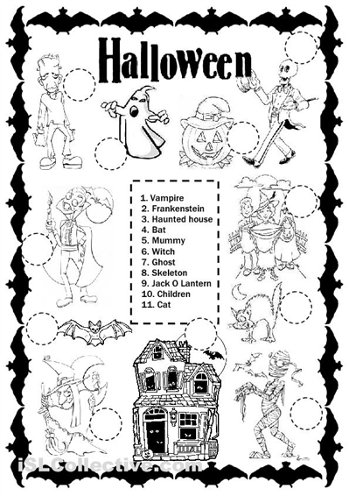

ACTIVITY 3: “WHO ARE YOU?”
ORAL INTERACTION
Timing: 15 minutes | Materials: Flashcards with the Halloween’s characters. | Grouping: All the class
Development: Children are around the class, every child has a flashcard, for instance: happy ghost or sad monster. They have to ask to their partners: “Who are you?” and they have to answer. They have to find. Finally they have to match all the pictures.
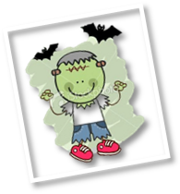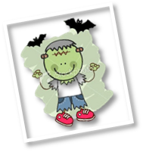
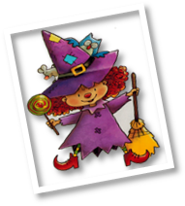
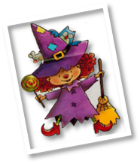

3.3. Summary stage

Sesión 10

ACTIVITY 1 : “HELLO, I AM A…”
ORAL INTERACTION
Timing: 15 minutes | Materials: Flashcards with the Halloween’s characters. | Grouping: All the class
Development: Children are in a circle. Every child has a flashcard with an emotion and a character. They have to say each other: “Hello, I am a happy monster” and the child who is on the right to him has to say: “Hello happy monster, I am a sad vampire”. The same with all the child in the circle.
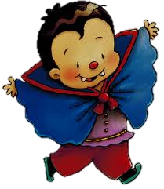

Activity 2: “THE SEPARATE PICTURES”.
WRITING
Timing 10 minutes | Materials: a copy with the images. | Grouping: individual
Development: we give to children a copy with two columns. In each column we have pictures about Halloween and they have to join one image of a column with the image in the other column, and these two pictures have to be related. They have to recognize the common element.
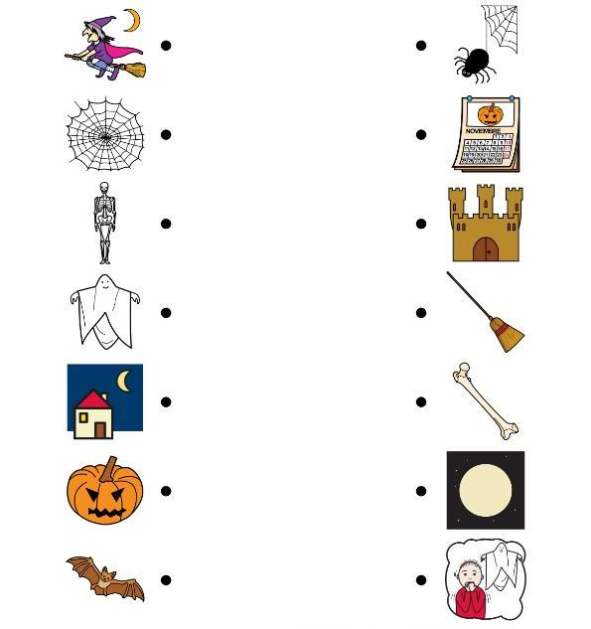

ACTIVITY 3: “ARE YOU…?”
ORAL INTERACTION
Timing: 10 minutes | Materials: Flashcards with the Halloween’s characters. | Grouping: All the class
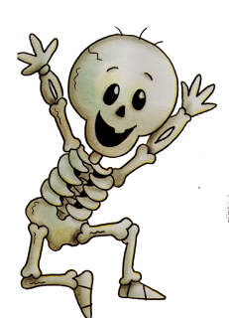Development: One child goes to the teacher´s table and pick up two flashcards, one with an emotion and the other one with a character. The rest of the class has to guess the emotion and the character, asking to the child: “are you…?

Sesión 11

Activity: Pumpking Puzzle
WRITING
Timing 10 minutes | Materials: a copy with the puzzle. | Grouping: individual
Development: we give to children a copy with a puzzles of Halloween and they have to color it and recognize the elements of the picture. Then, they have to cut the puzzle and they must do it again.
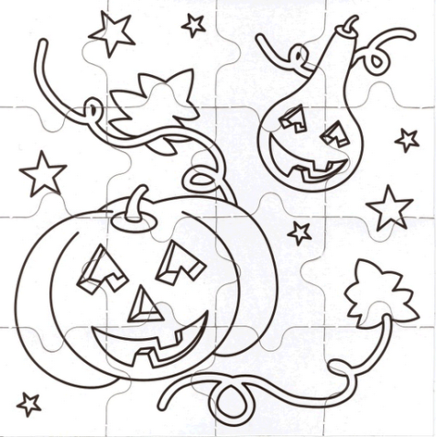

Activity 2: “MACH THE NAME WITH HIS PICTURE”.
READING
Timing 5 minutes | Materials: a copy with the name of the pictures and the pictures, scissor and glue. | Grouping: pairs.
Development: Children are in pairs, each group of children has a copy with a character of the story and they have to join them with their word. First of all they have to cut the words with the scissor and then stick them in the correct place.

Activity 6 RUN FAST.
LISTENING
Timing: 20 minutes | Materials: kerchief | Grouping: two group of 12
Development: In this game children are in two groups and the teacher is in the middle of this two groups. Each child has a little flashcard around their neck with a picture related to the vocabulary for example one pictures with a happy monster, a sad witch, happy witch, tec. and when teacher says the name to the picture, children who have this picture
must run to the teacher and catch the handkerchief that the teacher have in his hand and run to him group.

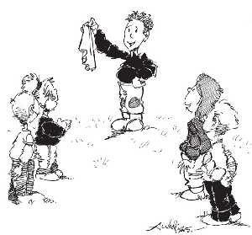

3.4. Generalization stage

Sesión 12

Activity 1 “FINAL TASK”.
LISTENING
Timing: 35 min | Materials: pc, pictures with the characters of the story, colors, voices of the children. | Grouping: all the class.
Development: Children have to color the pictures. Then with the help of the teacher they have to record their voices. Finally the teacher has to create a movie with movie maker.

- EXTENSION ACTIVITIES.
Activity 1: “WHAT IS DIFFERENT”.
READING
Timing 10 minutes | Materials: copy | Grouping: individual
Development: In this activity children have to look at the Halloween pictures in each row, and then they have to circle the picture that is different from the others in each row.

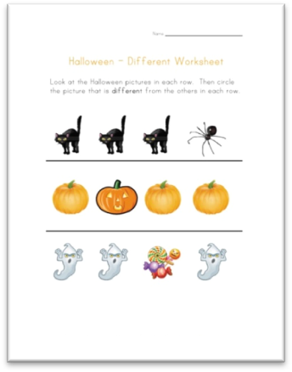

Activity 2: “PUMPKIN PUZZLE”
WRITING
Timing 15 minutes | Materials: a copy with the puzzle. | Grouping: individual
Development: we give to children a copy with a puzzles of Halloween and they have to color it and recognize the elements of the picture. Then, they have to cut the puzzle and they must do it again.

Activity 3: “CUT OUT”.
Timing 15 minutes | Materials: a copy with the cut out and fasteners. | Grouping: individual
Development: We give to the children a copy with a cut out of an skeleton and they have to cut it and put all the pieces together.
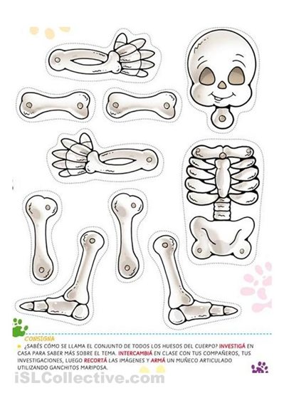

Activity 4: “CUT OUT”.
Timing 15 minutes | Materials: a copy with the mask | Grouping: individual
Development: We give to the children a copy with a cut out of a halloween mask

- REINFORCEMENT ACTIVITIES.

Activity 1: “WRITTEN WORDS”
WRITING
Timing 10 minutes | Materials: a copy | Grouping: individual
Development: We give to children a copy and they have to fill the missing vowels foe each Halloween word.
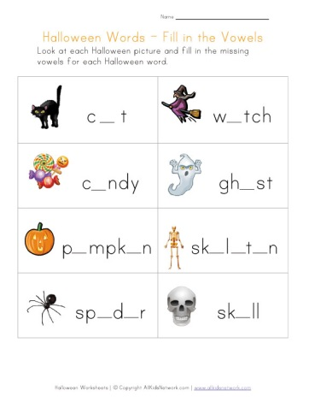

Activity 2: “WRITTEN WORDS 2”.
WRITING
Timing 10 minutes | Materials: a copy | Grouping: individual
Development: We give to children a copy and they have to write down all the Halloween words.
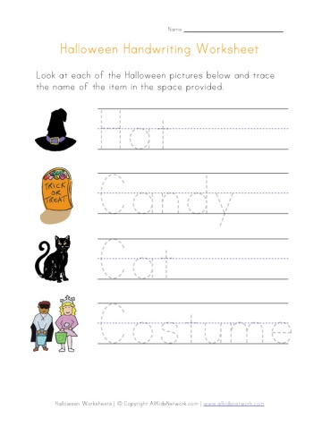

Activity 3: “LET´S COUNT”.
WRITING
Timing 15 minutes | Materials: a copy | Grouping: individual
Development: We give to children a copy and they have to count how many pictures are there in each square and make a circle in the correct number.

4.- EVALUATION
Now we are going to show the distribution of the indicators taking into account the different
evaluation tools. When indicators are associated to an evaluation test, an exam should be
designed in order to have a clear evaluation of each indicator which is related to a specific activity.
In addition, we can include the indicators that will be evaluated in each session.

Direct observation

 | Sessions | Mark
C1.1 To use the foreign language to interact with adults
C1.2 To use the foreign language to participate in conversations with adults and peers
C2.1 To understand oral messages
C2.2 To show an active and respectful attitude of listening and communication
C3.1 To enjoy listening literally texts
C3.2 To enjoy reading literally texts
C4.1 To communicate throw different materials and Techniques

C4.19. To sing songs

C5.13. To play games

Projects

 |  | Sessions |  | Mark
C1.1 To use the foreign language to interact with adults
C2.1 To understand oral messages
C4.1 To communicate throw different materials and Techniques

Participation

 | Sessions | Mark
C1.1 To use the foreign language to interact with adults
C1.2 To use the foreign language to participate in
conversations with adults and peers
C2.1 To understand oral messages
C2.2 To show an active and respectful attitude of listening and communication
C3.1 To enjoy listening literally texts
C4.1 To communicate throw different materials and Techniques

C4.19. To sing songs

C5.13. To play games

