UNIT OF WORK
A trip to the Planets!
2013/2014 – 3rd cycle of primary
(Group 8)

INDEX

- CURRICULUM MODELS.

  - Objectives per area.
  - Didactic objectives for our Unit of Work.

- LEARNING ELEMENTS. INDICATORS FOR THE EVALUATION OF OUR UNIT OF WORK.

- NUMBER OF SESSIONS AND THEIR DEVELOPMENT.

3.1 Initial Stage.
3.2 Development Stage.
3.3 Generalization Stage. Summary Stage.

- ASSESSMENT.

- BIBLIOGRAPHY.

1. Curriculum Models
We are going to include 3 blocks compiling, in one side the objectives, criteria and competences established in our Didactic Programming for this Unit of Work, in another side didactic objectives which are going to get developed, and finally contents blocks which are going to be worked.

1.1. Objectives per area, General Evaluation criteria and competences programmed in this Unit.
Here we have the objectives, evaluation criteria and competences related with our Didactic Programming. In this way, we have the information planned from the Didactic Programming which is going to help us in order to design the development of the Unit of Work in an integrative way.

Objectives per area | Evaluation Criteria | Competences
Objective 1. To listen and to understand oral messages, in different communication contexts, to make simple and diverse tasks and adopting a formal and cooperative attitude.  Objective 2. To express orally in an appropriate, coherent and polite way in usual situations integrating verbal and non-verbal procedures, using phonetic aspects of rhythm, accentuation and intonation as basic elements of communication.  Objective 3. To read in an expressive and comprehensive way diverse texts related with their experiences and interests extracting general and specific pieces of information according to previous purpose.  Objective 4. To write in an appropriate, coherent and polite way, with patterns as help, diverse texts with a varied purposes that are related with the student's interest and experience.  Objective 5. To use with autonomy all the conventional means, communicative and information technologies to obtain and to submit diverse information and to communicate in a foreign language.  Objective 6. To value the foreign language and languages in general as a mean of communication and understanding among people from various origins and cultures, avoiding any kind of discrimination and linguistic stereotypes.  Objective 7. To expound a receptive, interested and confident attitude in the own learning capacity and use of the foreign language and to use knowledge and previous experiences with other languages for a faster, more efficient and more autonomous acquisition of the foreign language.  Objective 8. To use reading in a foreign language as a pleasure and personal enrichment resource.  Objective 9. To use languages as a communication and learning conductor in the rest of areas. (Bilingual schools). | Criterion 1. To keep quotidian and familiar conversations about known themes in a predictable situation of communication, respecting basic exchange rules, as listen and look at who talks.  Criterion 2. To understand the global sense and identify specific informations in varied oral texts played in different situations of communication.  Criterion 3. To use basic forms and structures suitable of a foreign language including rhythm, emphasis and intonation aspects in different communicative contexts in a significant way.  Criterion 4. To read and find explicit information and achieve direct inferences in understand diverse texts about interest themes.  Criterion 5. To develop written texts attending to the addressee, type and purpose of the text, both support paper and digital.  Criterion 6. To use some strategies for learning to learn, as to do relevant questions in order to obtain information, to ask for clarification, using bilingual and monolingual dictionaries, accompanying communication with gestures, to search, to collect and organize information in different formats, to use ICT in order to compare and verify information, and identify some aspects that help you to learn better.  Criterion 7. To assess the foreign language as a means of communication with other people, as a learning tool and show curiosity and interest towards people who speaks the foreign language.  Criterion 8. To show interest and curiosity to learn the foreign language.  Criterion 9. To read on the own initiative different types of texts, to use and manage with ease libraries, video libraries, and so on. And understand the mechanisms and procedures of organization and selection of books and other materials. To collaborate in the care and improvement of library materials and other documents available in the classroom and in the school.  Criterion 10. To use the foreign language to know and communicate the contents of other areas. | - Communicative Language Competence  - Mathematical competence  - Competence in the knowledge and interaction with the world  - Digital and information processing competence  - Social and civic competence  - Cultural and artistic competence  - Learning to learn competence  - Autonomy and personal initiative competence  - Emotional competence

1.2. Didactic objectives of our Unit of Work

Adapted Objectives
1. To listening to understand the story “a trip to the planets: Bob the astronaut” to learn the planets in the correct order answering the questions proposed.
2. To talk about the vocabulary related with the Unit using superlatives and “wh-“ questions singing the song “The planets” and the chant “zoom, zoom, zoom”.
3. To read the story in Photopeach “The Big Bang” being able to understand it and answer the questions of the worksheet.
4. To write a comic with Pixton about the differences of planets following a model to show it to your partners.
5. To look for some information on the internet about the planets to make a mobile or model. Ask our students to use Voki or Gloster to do some activities.
6. To value English as a mean of communication and enrichment, to be conscious of our place in the Universe and the importance of care our planet, The Earth.
7. To show a confident attitude talking and writing about the Solar System and the space.
8. To read the “The intergalactic Supermassive space Book” as a resource of pleasure.

1.3. Content blocks worked in the Unit of Work.

Content Blocks
The contents that are worked in the fifth grade of the 3rd cycle of Primary Education in the English Area are the followings:

BLOCK 1: Oral Communication: Listening, Speaking and Oral interaction.

Oral Communication

Listening:

- Listening and understanding oral messages of progressive complex, as instructions or explanations, supervised interactions or audio-visual and informatics recordings to obtain global information and specific information.
- Development of basic strategies to support oral understanding. Use of the visual and no verbal context, from the previous knowledge about the topic or situation, transferred from languages that they know to the foreign language.

Speaking:

- Producing oral texts with progressive autonomy, effectiveness and complexity based on known models and linguistics structures.
- Interest of careful pronunciation and appropriate accentuation, as much in oral interaction and oral expression as in recitation and dramatization.
- Use of skills and procedures as repetition, memorization, word association with gestural and visual elements, observation of models to acquire new lexis forms and language structures.

Oral Interaction:

- Oral interaction in real situations or simulated with progressive autonomy, effectiveness and complexity of the used expressions.
- Development of basic strategies to support the understanding and oral expression. Use of a visual and no verbal context and the previous knowledge of the topic or situation that are transferred from the known language to the foreign language.
- Disposition to overcome difficulties that usually emerge in communication, using communicative strategies of the know languages.
- Knowledge of daily customs and use of relationship social forms of their own countries where they speaks the foreign language.
- Showing a receptive attitude and a positive assessment towards people who speak a foreign language and have a different culture.
- Interest to be in contact with people who speak the foreign language or other languages through resources that communication technology provides.
- Valuing the foreign language or other languages as a resource of communication and to be in contact with classmates from another country, as a possibility of access to new information and as a tool to know cultures and ways of living that are different and enriching.
- Showing interest in using a foreign language properly in various situations in individual or group activities.

BLOCK 2: Written Communication: Reading and Writing.

Written Communication

Reading

- Association of spelling, pronunciation and meaning from written models, known oral expressions, establishment of analytics spelling-sound relations and knowing of some relevant irregularities.
- Careful pronunciation, property rhythm, intonation, and accentuation in reading aloud.
- A progressively autonomous use of reading strategies. (Elements of visual context, previous knowledge of a topic or situation transferred from known languages.) To identify the most relevant information, Deducing words meaning and unknown expressions and the use of dictionaries.
- The progressive use of spelling resources of reference and information and the possibilities that technologies offers.
- The use of skills and procedures as the utilization of supports and information technologies and communication for the acquisition of new lexis, forms, and language’s structures, text’s reading.

Writing

- Writing of own texts from daily situations of social relations, from mass media and text for learning and for have information.
- Compositions of own texts from different situations of communication, progressively more widespread and rich in lexis and structures to transmit information with communicative diverse intentions.
- Utilization of basic strategies of the text’s production (Election of the addressee, purpose, planning, to redact a rough draft, review of the text and final version) from models.
- Use of the information and communication technologies for reading, writing and to transmit information.
- Showing interest for the care and writing texts presentation and to assess the role that plays to satisfy the communication needs.
- Assessing the foreign language as a tool to communicate and to learn.

BLOCK 3: Knowledge and reflection on the use of language.

- Comparison and reflection on working of the foreign language from the known languages.
- Reflection on their own learning, organization of the work, acceptance their own mistakes as part of the process of learning, auto correction and self-evaluation.
- Showing self-confidence in the own capacity of learning a foreign language and to assess the cooperative learning.

2. Learning elements. Indicators for the assessment of the Unit of Work.

At the end of the Unit every child must be competent in:
Indicator C1.1. Respect rules of participation in virtual communities (TIC)
Indicator C1.2. Knowledge and acceptation of all group members. (SYC)
Indicator C1.3. Use specific vocabulary (COM)
Indicator C1.4. Use of grammatical structures (COM)
Indicator C1.5. Respect to the works and opinions of others (EC)
Indicator C2.1. Use of specific vocabulary (MAT)
Indicator C2.2. Performance of the time relations (MAT)
Indicator C3.1. Use of grammatical structures (COM)
Indicator C4.1. Barriers and interferences' identification (LL)
Indicator C5.1. Use of grammatical structures (COM)
Indicator C6.1. Use of the Internet as an information resource. (TIC)
Indicator C6.2. Work in a network (TIC)
Indicator C6.3. Comparison, classification materials (know)
Indicator C6.4. Distribution the process in phases, task and responsible ones. (Know)
Indicator C6.5. Barriers and interferences' identification (LL)
Indicator C6.6. Alternatives' searching (LL)
Indicator C6.7. Responsibility on tasks (AUT)
Indicator C6.8. Answers adapted on the critiques (AUT)
Indicator C6.9. Self-control of reaction and moods (EC)
Indicator C7.1. Identification and reject of any kind of prejudice. (SYC)
Indicator C7.2. Flexibility and participant behavior in problematic situations. (SYC)
Indicator C7.3. Assessment of the interest and content relevance (COM)
Indicator C7.4. Motivation's identification (LL)
Indicator C7.5. Alternatives searching (LL)
Indicator C7.6. Self-control of reaction and moods (EC)
Indicator C7.7. Respect to the other’s works and opinions (EC)
Indicator C8.1. Assessment of the interest and content relevance (COM)
Indicator C8.2. Motivation's identification (LL)
Indicator C8.3. Compliance of adopted accords (AUT)
Indicator C8.4. Responsibility on tasks (AUT)
Indicator C9.1. Assessment of the interest and content relevance (COM)
Indicator C9.2. Motivation's identification (LL)
Indicator C9.3. Responsibility on tasks (AUT)
Indicator C10.1. Use of specific vocabulary (COM, know, LL)
Indicator C10.2. Artistic project design (CYA)
Indicator C10.3. Selection and material preparation (CYA)
Indicator C10.4. Alternatives searching (LL)
Indicator C10.5. Responsibility on tasks (AUT)
3. Number of Sessions and their development.
We are going to develop this Unite of Work in 12 sessions. They are organized as:
Initial Stage | Development Stage | Summary Stage | Generalization Stage
1 | 7 | 3 | 1

3.1. Initial Stage

Session 1

Activity 1. Greeting: Silly Name game
Grouping | Sitting | Timing | Materials
Whole class | Class in circle | 10min. | -Flashcards
Development:
With the intention to meet each other in class, we have prepared a greeting activity.
First of all with the introduction of a new Unit of work teacher explains his or her purpose that is to meet each other in class.
First of all, we gather the children in a circle and we show them our flashcards pronouncing the word correctly and then they have to repeat it.
We are going to repeat the greeting 3 times. The first time will be an individual presentation (one by one) e.g. My name is Maria and you? The second time we give each child a flashcard that is going to be their part of their name (a possibility is to use rhyming or beginning with the same letter as the name). E.g. Hello, My name is “Muffin Maria “and you? The next child is going to repeat this structure using him flashcard: Hello, my name is crocodile Carlos and you? And so on.
Finally we divide them in groups of five students and they are going to introduce their selves and then they have to memorize their partner’s names. E.g. My name is Funny Fran and they are Rocket Raquel, Umbrella Estela and Cinderella Antonella. It's a fun way to know one another and learn everybody's names.

Activity 2. Present the task
Grouping |  | Sitting |  |  | Timing |  |  | Materials
Whole class |  | U-shape |  |  | 10min. |  |  | -Mobile planets patterns
Development: The teacher introduces the task and present the different materials and mobile’s models to the students.

Activity 3. What are we going to learn ???
Grouping |  |  | Sitting |  |  | Timing |  |  | Materials
Whole class |  |  | U-shape |  |  | 10min. |  |  | -Blackboard
Development: The teacher asks some open questions in order to know what the children know about the topic. It’s a brainstorming activity.
-What do you know about the Universe? And about the solar System? What is “The Big Bang theory”? What is the NASA?

Activity 4. What are we going to learn?
Grouping | Sitting |  |  | Timing |  |  | Materials
Whole class | U-shape |  |  | 10min. |  |  | -Blackboard  -Flashcards
Development: The teacher explains what contents and structures the students are going to learn related to the topic. Superlative structures, ordinal structures and vocabulary related to the space.

3.2. Development Stage.

Session 2
Activity 5. Vocabulary box
Grouping | Sitting | Timing | Materials
Whole group | U-shape | 5min. | -Box, flashcards.
Development:
It is a listening and speaking activity, and we will take 5 minutes to carry on the activity. The materials that we need are a box and some flashcards related with the vocabulary of the topic.
We will have a fun box with flashcards into it, and we will take out one by one in order to create expectations. We will show the children the flashcards, pronouncing the word with the correct pronunciation and then they must repeat the pronunciation of the word as correct as possible, and associate it with the picture.
We can repeat the activity two times and change some things. For example, we can cover up the name in the flashcard and they have to guess it with pronouncing it correctly.

Activity 6. A trip to the planets story (1)
Grouping | Sitting | Timing | Materials
Whole class | U-shape | 15min. | -story, flashcards, puppets, questions.
Development: The teacher presents the characters, tell the story and after that, children have to answer some questions related to the story:
-Which are the main characters?
-How did they arrive to Mars?
-Which was the secret code?
-What does the code mean?

A TRIP TO THE PLANETS!
Bob the astronaut and his assistant Betty the Monkey wanted to visit all the planets of the solar system. They started their space trip on the biggest and the fastest spaceship of our planet Earth.
-Betty, the trip to Mars is long and I’m so tired! I’m going to sleep a little bit. HmmmmZZZZZZZZZZzzzzzzzzz
-Ohhh Where are we!? Betty? What planet is it? Is it Mars?
Betty pointed to letter V on the keyboard.
-Oh!! We are close to Venus! We are lost!
-Oh! Look! A message from the Earth!
“Piiiiiiiiiiiiiiiiiiiiiiiiiiiiiiiiiiiiiiiiiiiiii!!!!! Bob, you must follow the next code: My Very Educated Mother Just Served Us Nachos. Good luck!”
Bob and Betty look at each other.
-My Very Educated Mother Just Served Us Nachos? What does it means?
Bob wrote the code on the blackboard.
Betty: Hmmmmmm! Betty pointed to the Capital letters.
-Betty! You are so clever! It is the planets order! We go the Earth!
-“My Very Educated Mother Just Served Us Nachos.”
“Mercury, Venus, Earth, Mars, Jupiter, Saturn, Uranus and Neptune! That’s it!
-Hey you! From the Earth! Could you help us to order the planets please? We want to go to the Earth!
(Students help us to order the planets)

- So, Mercury is the nearest to the Sun and, Venus, Earth, Mars, Jupiter the biggest, Saturn, Uranus and Neptune!
- Hurrah! Well done, Betty! We go back home! Great job! Take a banana!
-Yummy!!!!
-Look Betty, the Earth! No, no… it’s an alien. We are in Mars…Hello Mr alien!
-Hello Bob! How are you?
-Fine thanks! We go to the Earth!
-Oh! Have a nice trip! See you!
-Bye Mr. Alien!
And finally Bob the astronaut and Betty the monkey arrived on the Earth in time for dinner.

Activity 7. Superlatives
Grouping | Sitting | Timing | Materials
Whole class | In rows | 15min. | -flashcards
Development: The teacher asks to the students about something that he/she is or not is using the superlatives. e.g.:
-Who is the tallest person in your family?
- I am the tallest in my family.
-Who is the happiest person in your family?
-My sister is the happiest.

Using the flashcards with the superlatives, children will ask and answer the questions.

Who is _________________ in your family?

Happy the happiest
Funny the funniest
Old the oldest
Tall the tallest
Small the smallest

Pupils will pass to her/his partner the flashcard and repeat the question.
Activity 8. Draw my alien
Grouping | Sitting | Timing | Materials
In groups of 5 | In groups | 15min. | -paper sheets, pencil, colors. Barrier screen, flashcards.
Development: One child is the instructor and has the set of visual instructions to use to help their team member/s to draw in a progressive or step by step manner. The instructor describes each part of the drawing as best as they can. He/she has to use different adjectives and superlatives: colour, size, shape, location.
Two variations of this drawing barrier game are:
• The instructor can see the drawing and adjusts the instructions.
• The instructor does not see the drawing and only sees the final drawing.

Variation: work in pairs.
Roles: change roles.

Session 3
Activity 9. A trip to the planets story (2)
Grouping | Sitting | Timing | Materials
Whole class | In rows | 10 mins | -story, flashcards of planets, puppets
Development: The teacher tells the story and interacts with children in order to number the planets from the Sun in the Solar System, using the numerals and superlatives. Asking questions as: Can you help me to order the planets?
Which is the nearest planet to the Sun? Which is the farthest planet from the Sun?
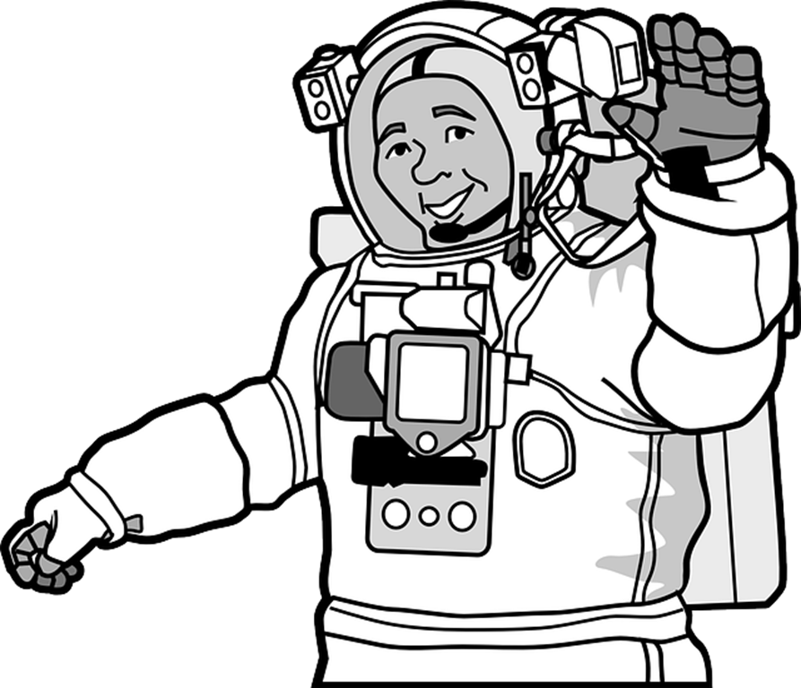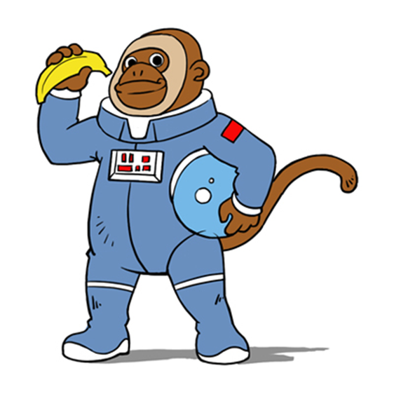

Activity 10. “Zoom zoom zoom” chant (1)
Grouping | Sitting | Timing | Materials
Whole class | In circle | 5 min. | -chant
Development: The students have to sing the chant listening to the teacher and following the teacher’s gestures (twice).

Zoom, Zoom, Zoom

Zoom, zoom, zoom,
The planets are too cool.
Zoom, zoom, zoom,
The farthest is Neptune.
If you want to take a trip,
Climb aboard my rocket ship.
Zoom, zoom, zoom,
The prettiest is Saturn!

Activity 11. The Planets song (1)
Grouping | Sitting | Timing | Materials
Whole class | In U-shape | 5 min. | -video support
Development: Students listen to the audio and sing the song aloud accompanied with the teacher. He/she can introduce some gestures and perform the lyrics.

http://www.youtube.com/watch?v=tNlhqPz5-Kw

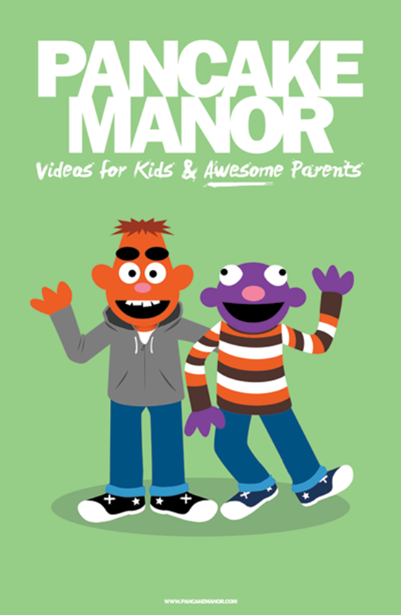

Activity 12. Dictation
Grouping | Sitting | Timing | Materials
Solo work. | In rows | 20 mins. | -Dictation, sheets and pen
Development: At first, children have to listen to the text. In the second time, children must write what we say. We are going to dictate with a slower rhythm and repeat the sentences if they ask about it. In the last time, we are going to read all the text with a normal rhythm. Finally, we are going to show them the text in the digital board and they must to correct their mistakes.

“Bob the astronaut and Betty the Monkey travel around the planets in the Solar System. They know that the Sun is the brightest star near The Earth and it is very hot. They like Mercury so much because is the closest planet to The Earth. And they have a code for their travels: My Very Educated Mother Just Served Us Nachos.”

Activity 13. Bingo
Grouping | Sitting | Timing | Materials
Whole class | In U-shape | 10min. | -Bingo templates, box, flashcards
Development: Each child has a bingo template. The teacher picks up a flashcard with a word related to the space from the box and says it aloud.
When the student has the written word in his/her template, he/she has to cross out and so on. The first student who cross out the complete template wins.
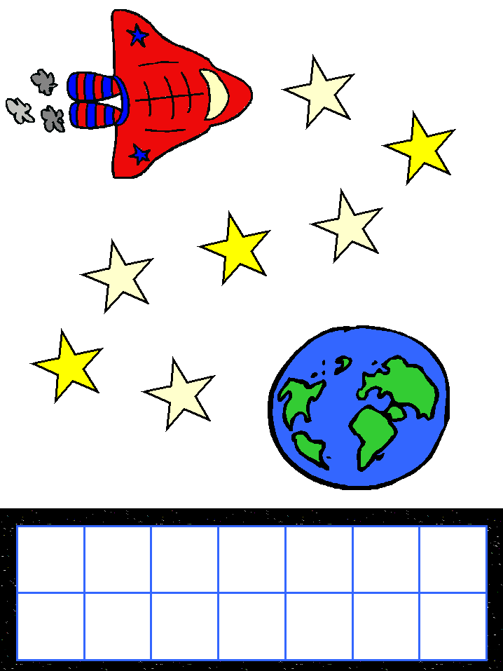

Session 4
Activity 14. The Planets song (2)
Grouping | Sitting | Timing | Materials
Solo work/  Whole class | In rows | 15 min. | -audio aids, lyrics worksheet with gaps
Development: Students listen to the song and sing it aloud with the lyrics. They have to fill in the gaps the missing words.

We live in the Solar System
In the centre is the Sun
All the planets move around it
We’ve seen every single one

Orbit in the big bright Sun (x2)

Planets in the solar system
1, 2, 3, 4, 5, 6, 7, 8
Telescope they help us to see them
We’ve seen every single one

Orbit in the big bright Sun (x2)

Mercury, Venus and Earth
And Mars and Jupiter and Saturn
Uranus too…
And don’t forget that pretty blue…Neptune

We live in the Solar System
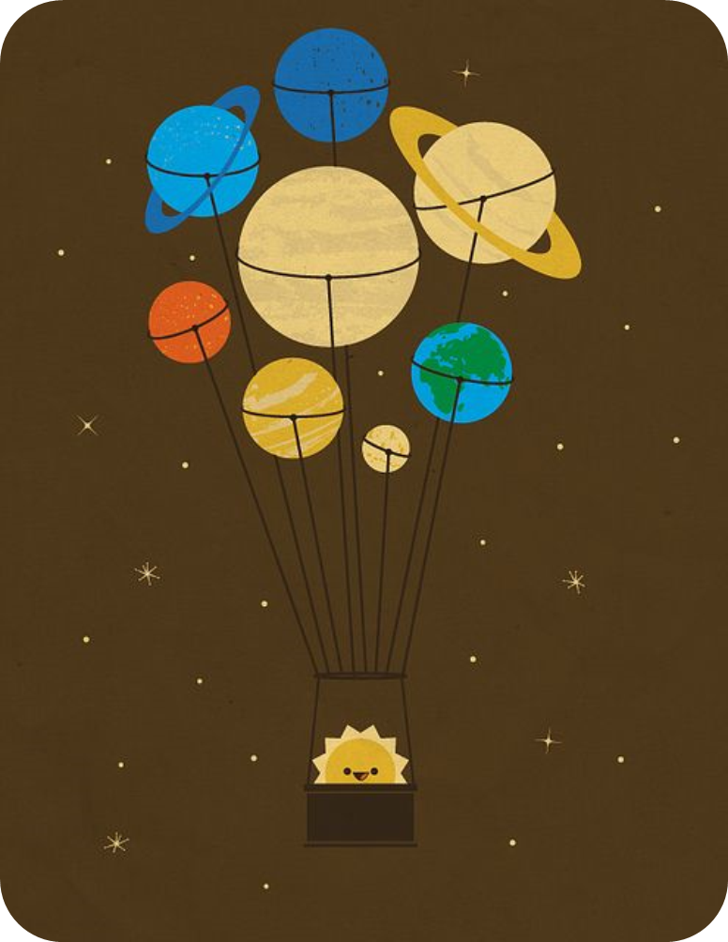
In the centre is the Sun
All the planets move around it
We’ve seen every single one

Orbit in the big bright Sun (x2)

http://www.youtube.com/watch?v=tNlhqPz5-Kw We will play it twice.

Activity 15. “Zoom zoom zoom” chant (2)
Grouping | Sitting | Timing | Materials
Groups of 5 | In groups | 10 min. | -chant, blackboard
Development: Each group has to sing the chant and create a new strophe being creative. Finally they sing aloud the chant and perform it. The others groups have to evaluate and decide which one are the best performance and lyrics.

Zoom, Zoom, Zoom

Zoom, zoom, zoom,
The planets are too cool.
Zoom, zoom, zoom,
The farthest is Neptune.
If you want to take a trip,
Climb aboard my rocket ship.
Zoom, zoom, zoom,
The prettiest is Saturn!

Activity 16. Make your mobile
Grouping | Sitting | Timing | Materials
In groups of 5 | In groups | 15min. | Old CD, Styrofoam Ball (cut in half).Paint (glow in the dark if it is possible) Fishing Line or Dental Floss.
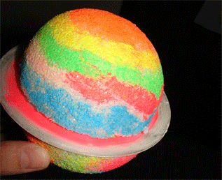
We are going to make our own planet following the next steps:
Step 1
Get a Styrofoam ball and choose an old CD that you no longer need.
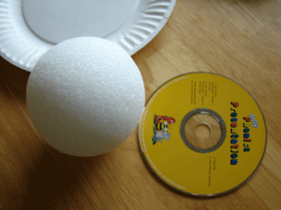
Step 2
Slice your ball in half with a knife....be careful. Teacher will help you at this step.
Step 3
Use you're Glow in the Dark paint to add colours all around the planet.
We must remind children why planets are different colours.
Step 4
Paint both sides of your CD with paint.
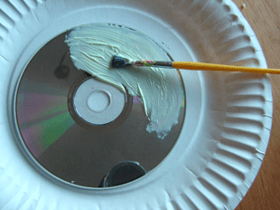
Glue your two halves to the cd, and you've got a fun planet you can
hang in your room. Using a needle and fishing wire to make it look like
it's hanging in the air.

Activity 17. Story box
Grouping | Sitting | Timing | Materials
In groups 5 | In groups | 10 mins | -box, different objects, paper sheets.
Development: The teacher shows a box full of different objects, characters, some of them related to the space. In groups they have to collect 3 objects of the box per group and build a story involving the 3 objects picked up previously.
After elaborate the story, they have to perform it to the rest of the class.

Session 5

Activity 18. “The Big Bang theory”
Grouping | Sitting | Timing | Materials
Solo work/pairs | In pairs | 15 min. | -worksheets, computer, projector, Photopeach reading.
http://photopeach.com/album/pu05a1?invitecode=82fc419e82

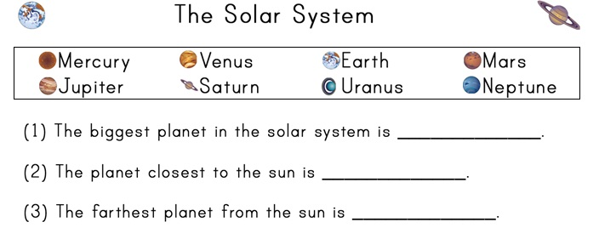
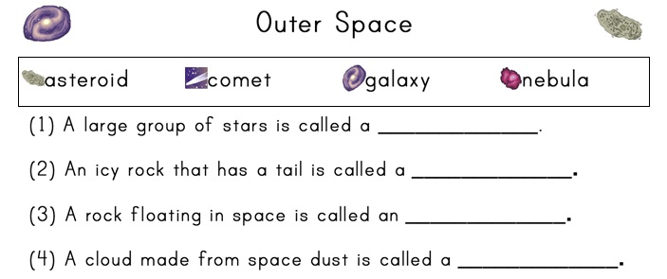

Activity 19. Explores the space!
Grouping | Sitting | Timing | Materials
Solo work/pairs | In pairs | 5 min. | -Althea room
Development: Children have to listen to the different pictures and match the words with them according to the information given.
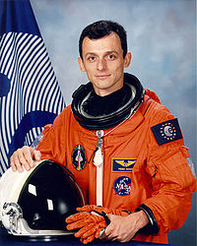
http://dearstudents2012.blogspot.com.es/2013/12/group-8-lim-activity.html

Activity 20. Voki speaks with you.
Grouping | Sitting | Timing | Materials
Solo work/ pairs | In pairs | 10min. | -Althea room
Development: Pupils have to listen and speak to Voki answering its questions.

http://www.voki.com/php/viewmessage/?chsm=3be4d2e7138bab285ea8ad4df35bc6a0&mId=1984587

Activity 21. Create a comic!
Grouping | Sitting | Timing | Materials
pairs | In pairs | 20 min. | -Althea room
Development: Children have to read the comic and elaborate their own comic using superlatives and the structures given in this Unit.
They will have to use the following model:

http://www.pixton.com/es/embed/1ihlir7i

Session 6

Activity 22. A trip to the planets! (3)
Grouping | Sitting | Timing | Materials
Groups of 5 | Groups | 20 min. | -story, flashcards
Development: Students have to elaborate their own story related to space and make a book using pictures with their own materials as homework. They will present the book to the rest of the class. They can use the same story, chance it or invent a different one.
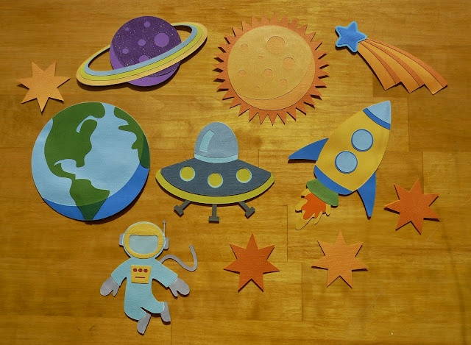

Activity 23. The Planets song (3)
Grouping | Sitting | Timing | Materials
Groups of 5 | In groups | 10 min. | -Youtube video  computer
Development: Students have to sing the song aloud in groups when the teacher points them. In the second listening, students have to perform and sing the song and the whole group will choose the most creative and original performing.

http://www.youtube.com/watch?v=tNlhqPz5-Kw

Activity 24. “Zoom zoom zoom” chant (3)
Grouping | Sitting | Timing | Materials
Groups of 5 | Circle | 5 min. | -chant
Development: In groups sing aloud the chant with different voices.

Zoom, Zoom, Zoom

Zoom, zoom, zoom,
The planets are too cool.
Zoom, zoom, zoom,
The farthest is Neptune.
If you want to take a trip,
Climb aboard my rocket ship.
Zoom, zoom, zoom,
The prettiest is Saturn!

Activity 25. “Planets cut out”
Grouping | Sitting | Timing | Materials
In pairs | In pairs | 20 min. | -Scissors, colors, notebook, paste, worksheet
Development: Children have to colour and cut out the planets with their names. Then, they will paste them in their notebooks in order from the Sun.(1)
After that, they have to fill in the gaps with the correct superlatives and ordinal numbers (2, 3). Finally, they have to interact orally in pairs by asking and answering the questions (4).
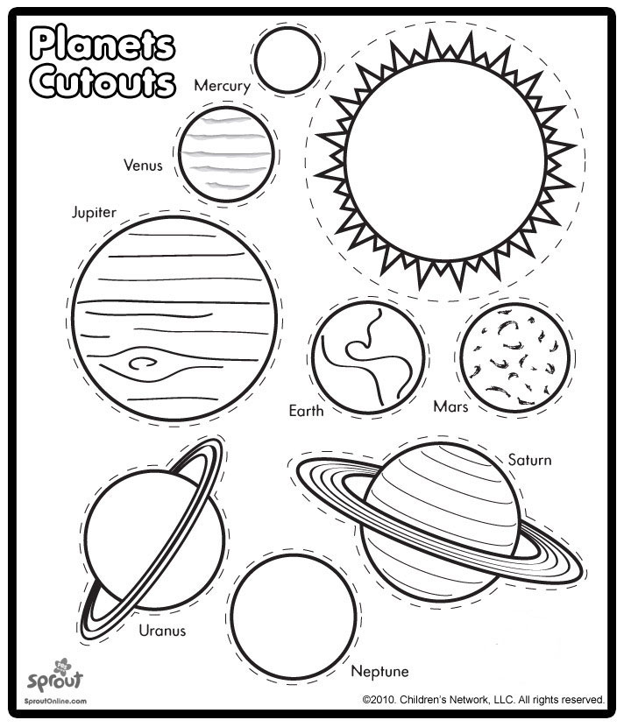
- Cut out the planets and their names along the lines around the planets and put them in order from the sun to the furthest one. Then coloured the planets and paste them in your notebook.

- Fill in the gaps with the correct superlative:
- Uranus is the ____________________________ planet from the Sun.
- Mercury is the ____________________________ planet to the Sun.
- Jupiter is the ____________________________ planet of the Solar System.
- Mercury is the ___________________________ planet of the Solar System.

- Fill in the gaps with the correct ordinal number:
- Jupiter is the ________________ planet from the Sun.
- Neptune is the _______________ planet from the Sun.
- Mars is the _______________ planet from the Sun.
- The Earth is the ________________ planet from the Sun.
- Saturn is the _______________ planet from the Sun.
- Venus is the _______________ planet from the Sun.
- Mercury is the ________________ planet from the Sun.
- Uranus is the _______________ planet from the Sun.

- In pairs, ask and answer each question:
How many planets are there in the Solar System?
Do you know which is the biggest planet of the Solar System?
Do you know which is the smallest planet of the Solar System?
Do you know which is the third planet from the Sun?

Session 7
Activity 26. Planetarium
Grouping | Sitting | Timing | Materials
Whole class |  | All the session
Development: Children are going to visit the Science’s Museum and the Planetarium. First, there will be a guided tour throughout the Museum, where pupils will observe, learn and do the interactive activities offered by the Museum. After that, children will visit the Planetarium, where they will witness the impressive universe in such a way that they will be aware of its grandness.

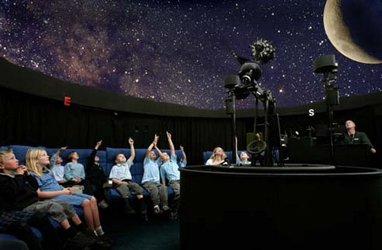

Session 8

Activity 27. Final task
Grouping | Sitting | Timing | Materials
In groups of 5 | In groups | 10min. | -Mobiles
Development: Each group has to present their mobiles of the Solar System to the whole class.
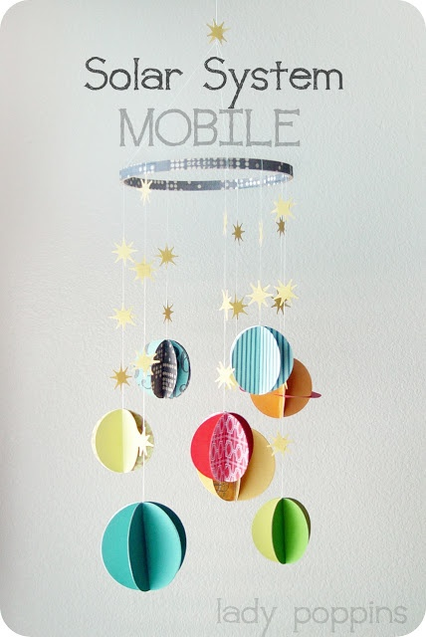

Activity 28. Performance of the story.
Grouping | Sitting | Timing | Materials
In groups of 5 | In groups | 40min. | -Mini books, stories
Development: Students in groups have to perform their own story using the materials they have elaborated before.
They can perform “A trip to the planets” or another they have chosen.

3.3. Summary Stage.

Session 9

Activity 29. Review activities.
Grouping | Sitting | Timing | Materials
Individual work | In rows | 10min. | Photocopies, glue, pencil, scissors.
Activity: Write a sentence which these adjectives in superlative form.
- (Large) _______________________________________.
- (Dark) _______________________________________.
- (Bright) _______________________________________.
- (Cold) _______________________________________.
- (Small) _______________________________________.
- (Heavy) _______________________________________.

Activity: Complete your word file
Constellation | (stick a picture)  space | __________________ | (stick a picture)  Jupiter
(stick a picture)  Earth | ______________ | (stick a picture)  Galaxy | _________________
________________ | (stick a picture)  Venus | _____________ | (stick a picture)  Neptune

Activity 30. “A letter to an alien”
Grouping | Sitting | Timing | Materials
Individual work | In pairs | 20 min. | -sheet of paper, pencil, dictionaries.
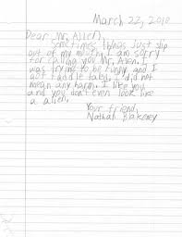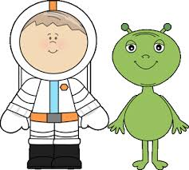
Development: Students have to write a letter addressed to an alien. Describing themselves and their daily routines and asking the alien some questions related to its life. Pupils must follow the model using superlatives and vocabulary.

Activity 31. “My dear alien”
Grouping | Sitting | Timing | Materials
In pairs | In pairs | 20 mins | -letters written in the activity “A letter to an alien”
Development: Students have to read aloud the written letters in pairs.

Session 10

EXAM
Grouping | Sitting | Timing | Materials
Solo work | In rows | All the session. | -Worksheets
- Read the biography. Match a paragraph to a picture.

Neil Armstrong.
- Neil Armstrong is a North American astronaut. He was born in Ohio in 1930. He was a pilot for the US Navy and Air Force. He was Command Pilot of the Gemini 8 space mission in 1966.

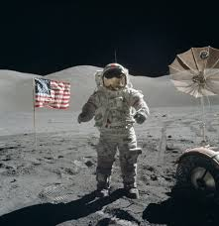
- Then, in July 1969, Armstrong was on the Apolo 11 lunar mission. The lunar module landed in the Mare Tranquilitatis. He was the first person to walk on the moon on the 20th of July. This was one small step for man and one biggest step for mankind.
A

- Choose the best title:
- Arthur Miller’s biography.
- A trip through the planets.
- Neil Armstrong is a policeman.
B
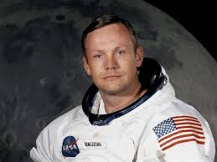
- The first astronaut who stepped the moon.

- The text presents…
- A trip to Jupiter.
- The astronaut finds a river in the moon.
- The biography of an astronaut.
- The singer Bob Dylan goes to the moon.

- The word “landed” means the same as…
- The rocket arrived to the moon.
- The rocker started to fly.
- Astronauts went back to the Earth.
- The rocket was travelling.

- Which is the most important idea of the text?
- The astronaut doesn’t step the moon.
- Neil Armstrong was the first to walk on the moon.
- Neil Armstrong was born in 1930.
- Apolo 11 was the furthest rocket.

- You can go to the moon…
- In November.
- With an astronaut.
- Nobody went to the moon.
- By plane.

- Listening activity
http://www.youtube.com/watch?v=h5bVZTpVxy4

Answer the questions:
- Choose the best title
- Learn about the Earth!
- The Sun, a very big ball of fire.
- The Solar System.
- All the planets move around the Sun…
- Because it is very hot.
- Because of the gravity of the Earth.
- Because it is the biggest Star.
- Because of the gravity of the Sun.
- The sun is…
- The only comet in the Solar System.
- The only planet in the Solar System.
- The only star in the Solar System.
- The only asteroid in the Solar System.
- Earth is…
- The fourth planet from the Sun.
- The third planet from the Sun.
- The first planet from the Sun.
- The fifth planet from the Sun.
- Earth is…
- The fifth biggest planet of the Solar System.
- The fifth smallest planet of the Solar System.
- The second biggest planet of the Solar System.
- The second smallest planet of the Solar System.
- The rocky bodies in the Solar System are…
- Planets.
- Stars.
- Asteroids.
- Galaxies.
- Universe is made by…
- Many people.
- Many asteroids.
- Many comets.
- Many galaxies.
- Writing activity.

3. Imagine an alien living in another planet. Describe him/her using the following words.

first | biggest | Red | eyes
third | nearest | Yellow | ears
fifth | farthest | Blue | feet

My favorite alien lives in…
His/her name is…
He/she has…
He/she likes…

- Planning the text:
Write some ideas about what you are going to write. You should include: alien description, planet description.

- Writing the text:

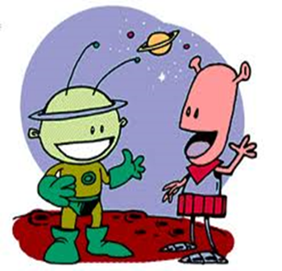

- Speaking and Oral interaction activity

Students will watch a video from the Pixar film “Wall-e”
http://www.youtube.com/watch?v=nLx_7wEmwms
Then they must discuss about the topic of the video giving some possible idea of what will happen to our planet, the environment and the Human Being in the future.
They will take notes their ideas, to agree with their partners, to make a list of advantages and disadvantages and to prepare an alternative plan for the future.
*Teacher can help them making questions to the groups.
Remember:
- Pay attention to the video and take the main idea.
- Write down your ideas briefly.
- Let’s exchange ideas in English.
- Give your list and notes to the teacher.

SELF-EVALUATION
Please complete the following tips with a TICK to know what you have learnt.

LISTENING, I can… | Tick
- Understand the words related with the planets.
- Recognize the names of the planets.
- Recognize the names of the Solar System elements.
- Understand the meaning of the story.
- Understand the letter of the song and the chant.
SPEAKING/ORAL INTERACTION, I can…
- Repeat the new vocabulary with an appropriate intonation.
- Sing the song and the chant by heart.
- Say hello and good bye in every lesson.
- Exchange opinions with other mates and my teacher.
- Ask about words that I don’t know about them.
WRITING, I can…
- Write the new vocabulary in a correct way.
- Write sentences related with the vocabulary of the unit.
- Write a comic with superlatives.
- Order the planet with ordinals (first, second,…)
READING, I can…
- Link words with their images.
- Read some words that I have learnt.
- Read a text related with the Solar System.
- Deduce the meaning of the words using the images that follow them in the text.
- Understand the global idea when I read the text.

*If they can do it they will write a tick at the final of every descriptor.

Session 11

Activity 32. Cinema Wall-e film
Grouping | Sitting | Timing | Materials
Whole class |  | 2Hours.
Development:
We will take our students to the cinema and they will watch the film “Wall-e” in English (voice and subtitles), about a robot (Wall-e) that travel throughout the space. This film is a touching science-fiction love story which contains important messages; e.g. protecting the environment.

3.4. Generalization Stage.

Session 12

Activity 33. Present the planets
Grouping | Sitting | Timing | Materials
Whole class | Class in circle | 10min. | -Flashcards
Development: The teacher takes a flashcard of a planet and says to a child:
- Hello! It is Mars.
-What?
-This is Mars.
-Oh!! It is Mars!
After that the student takes the flashcard and repeats the dialogue with his/her partner. Meanwhile the teacher starts the same dialogue with other student and another flashcard.

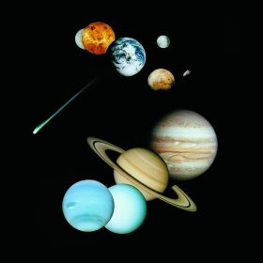

Activity 34. Quiz
Grouping | Sitting | Timing | Materials
Groups of 5 | In groups | 20min. | -Computer1 orange,1 punnet cherry tomatoes,1 punnet strawberries,1 banana,1 x 50g tin corn kernels, drained,3 x Mini Babybel cheese,1 punnet blueberries,1 small bunch green grapes,1 x blue plate
Development: We are going to use Voki for this activity.
They are going to be distributed in 4 groups, Voki is going to ask them some questions (10) in order, this is to say: the first group answers the first one, if they are right the leader of the group picks one fruit up and put it the plate as the picture on the screen; if they fail the turn will pass to the next group (group 2), and so on.

The objective is to build up a dish which represents the Solar System in a cooperative learning way. They have the motivation for working in a competitive way and the satisfaction for working in a cooperative way too.

http://www.voki.com/pickup.php?scid=9100443&height=267&width=200

Question 1

Which is the nearest planet from the Sun?
a) Venus
b) Mercury
c) Jupiter

Question 2
Which is the biggest planet?
a) Earth
b) Saturn
c) Jupiter

Question 3
Which element of the Solar System is the brightest?
a) The Sun
b) The planets
c) Monkey

Question 4
Which planet is between Venus and Mars?
a) Earth
b) Mercury
c) Uranus

Question 5
Which planet has got some rings?
a) Earth
b) Neptune
c) Saturn

Question 6
How can you trip to the planets?
a) We can’t
b) With a spaceship
c) Flying

Question 7
Which is the smallest planet of the Solar System?
a) Uranus
b) Saturn
c) Mercury

Question 8
Which is the pretty blue planet?
a) Neptune
b) Mars
c) Venus

Question 9
How many planets are there in the Solar System?
a) 2
b) 8
c) 5

Question 10
Which is the last planet?
a) Uranus
b) Pluto
c) Neptune

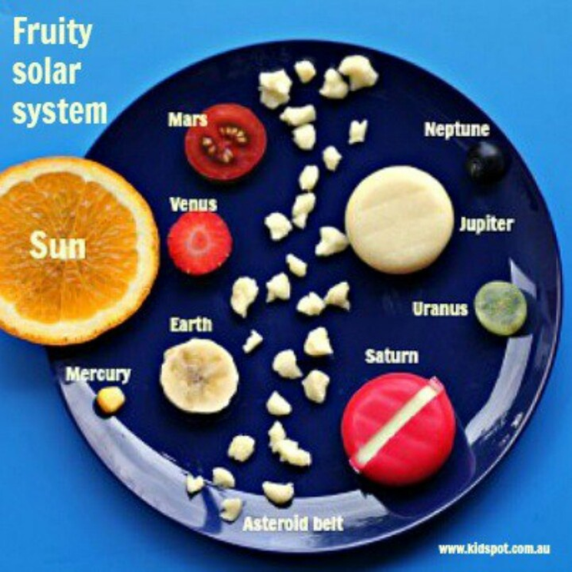

Activity 35. The Planets song (4)
Grouping | Sitting | Timing | Materials
Whole class | In circle | 5 min. | -audio aids
Development: Students must sing the song without lyrics.

http://www.youtube.com/watch?v=tNlhqPz5-Kw

Activity 36. “Zoom zoom zoom” chant (4)
Grouping | Sitting | Timing | Materials
Groups of 5 | In groups | 10 min. | - chant
Development: The whole group sings aloud the chant and in groups they have to create a new one and perform it in front of the class. With this activity we finish our unit.

Zoom, Zoom, Zoom
Zoom, zoom, zoom,
The planets are too cool.
Zoom, zoom, zoom,
The farthest is Neptune.
If you want to take a trip,
Climb aboard my rocket ship.
Zoom, zoom, zoom,
The prettiest is Saturn!

4. Assessment

We are going to evaluate if our students have reached objectives and basis competence using evaluation criteria and if they have reached the minimum levels.

Students will follow a continuous evaluation and they will be evaluated in three different ways. Types of evaluation:

- Initial evaluation: At the beginning of each unit to know the previous knowledge of the students.
- Formative evaluation: During each unit through direct observation. Teachers can include some extension and reinforcement activities to get the objectives.
- Summative evaluation: At the end of the didactic unit (an exam, a performance, the final task-outcome).

We have done the Initial evaluation of this unit (session 1, activity 3)
During the unit of work we have done the formative evaluation through direct observation and taking notes about different activities. We have used some extension and reinforcement activities trying to attend diversity in sessions 9 and 12.
And the summative evaluation with an exam in session 10, the acting out of the story in session 8 and we have done the students’ self-assessment using the Portfolio in session 10.
Now, we will make sure that we have worked all the indicators and we are going to give our students the mark of the evaluation of the unit.

Indicators evaluated with direct observation and classroom work | Sessions in which are evaluated
To respect rules of participation in virtual communities (competence in the knowledge and interaction with the word)  Use of the Internet as an information resource to work in a network (digital and information processing competence)  Knowledge and acceptation of all group members (social and civic competence)  Identification and reject of any kind of prejudice (social and civic competence)  A flexible and participant behavior in problematic situations (social and civic competence)  Selection and material preparation (cultural and artistic competence)  Alternatives searching (learning to learn competence)  Motivation's identification (learning to learn competence)  Responsibility on tasks (autonomy and personal initiative)  Answers adapted on the critiques (autonomy and personal initiative)  Compliance of adopted accords (Emotional competence)  Respect to the others works and opinions (emotional competence)  Self-control of reaction and moods (emotional competence) | Session 5  Session 5  Session 3. Activity 2  Session 6. Activity 1  Session 8. Final Task  Session 12. Quiz  Always in a continuous evaluation  Always in a continuous evaluation  Session 2. Draw an alien  Session 4. Arts and crafts  Session 6. Story with a book and pictures  + song and chant  Session 8. Final Task  Session 5  Session 6. Story with a book and pictures  Session 7  From session 1 to session 12  From session 2 to session 8  Always in a continuous evaluation  Always in a continuous evaluation  Always in a continuous evaluation  Always in a continuous evaluation

Indicators which are evaluated in a test | Questions in which are evaluated
Assessment of the interest and content  Relevance (communicative language competence)  Use of grammatical structures (communicative language competence)  Use of specific vocabulary (communicative language competence)  Distribution the process in phases, task and responsible (competence in the knowledge and interaction with the word)  Artistic project design (cultural and artistic competence)  Barriers and interferences identification (Learning to learn competence) | They are going to listen to a video in YouTube and select the best option in a multiple choice activity.  They are going to read two fragments and relate them with two pictures. Moreover, they must select the best option in a multiple choice activity.  They are going to write about an alien living in other planet, so they are going to describe it using pre-determinate words.  They must discuss about a video watched in YouTube. First of all, they will do a speaking and then an oral interaction.  Evaluated in all the exam activities  A mobile which will be evaluated among their partners and themselves  Trying to answer the questions they will improve their capacity of solving problems.

And we will evaluate these indicators in an objective way using this rubric of evaluation:

5th grade. Primary Education.
 | IN | SU | NT | SB
Speaking and oral interaction | He/she expresses with difficulties and the communica-tion is very poor. | He/she communicates in an acceptable way, but has some doubts, hesitation and mistakes. | He/she communicates effectively according to his/her level. | He/she can communicate without problems in all contexts.
Listening | He/she fairly broad understands dialogues in English. | He/she understands a lot of things but sometimes has doubts about the global understanding. | He/she understands all effectively according to his/her level. | He/she can understand all the listening and answer all of the questions.
Writing | He/she has difficulties with writing words or texts. | He/she writes the words correctly, but cannot write long texts in his/her level. | He/she can write correctly words and texts. | He/she can write all the words and long texts in a correct way.
Reading | He/she fairly broad reads words, sentences or texts. | He/she reads words, sentences or texts without fluency or intonation. | He/she reads in a correct way words, sentences and texts with fluency. | He/she reads in a correct way words, sentences and texts with fluency and a great intonation.
Grammar | He/she has difficulties with the grammar structure. | He/she can build simple structures. | He/she can build the structures studied according to his/her level. | He/she builds the grammar structure excellently.
Vocabulary | He/she has difficulties in the use and lack of vocabulary according to his/her level. | He/she can use the vocabulary in the unit but does not relate the vocabulary in all units. | He/she can use a great variety of words in the different topics. | He/she can use a great variety of words and can link a lot of vocabulary in all the situations.

Moreover, we have done the students’ self-assessment with the European Portfolio using the following descriptors:

LISTENING, I can… | Tick
- Understand the words related with the planets.
- Recognize the names of the planets.
- Recognize the names of the Solar System elements.
- Understand the meaning of the story.
- Understand the letter of the song and the chant.
SPEAKING/ORAL INTERACTION, I can…
- Repeat the new vocabulary with an appropriate intonation.
- Sing the song and the chant by heart.
- Say hello and good bye in every lesson.
- Exchange opinions with other mates and my teacher.
- Ask about words that I don’t know about them.
WRITING, I can…
- Write the new vocabulary in a correct way.
- Write sentences related with the vocabulary of the unit.
- Write a comic with superlatives.
- Order the planet with ordinals (first, second,…)
READING, I can…
- Link words with their images.
- Read some words that I have learnt.
- Read a text related with the Solar System.
- Deduce the meaning of the words using the images that follow them in the text.
- Understand the global idea when I read the text.
*If they can do it they will write a tick at the final of every descriptor.

BIBLIOGRAPHY

- Common European Framework of Reference for Languages: Learning, Teaching, Assessment (CEFR)
- European Language Portfolio for Primary Education
- Indicator system for the evaluation of the basic competences in Infant and Primary Education in Castilla La-Mancha
- 68/2007 Castilla La-Mancha decree
- Organic Law Education
- Ministry of Education and Science (MEC)

