NAME.-____________________________________2nd GRADE
EXTENSION ACTIVITIES
http://joseprat.jimdo.com/
CLICK on 1st and 2nd Primary and SING THE SONGS
Colours
The apple is red
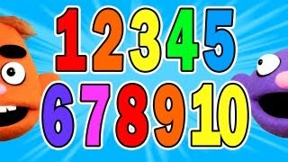 NUMBERS from 1 to 10
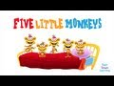 FIVE LITTLE MONKEYS
FINGER FAMILY
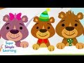 TEN IN THE BED
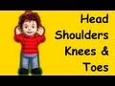 HEAD AND SHOULDERS , KNEES AND TOES
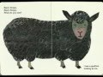 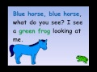BROWN BEAR , BROWN BEAR
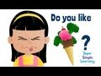 DO YOU LIKE?
I like painting
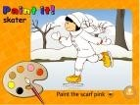
GAMES Maze: PETS, FOOD and NUMBERS
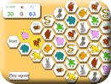
Where´s my bear?

https://www.youtube.com/watch?v=Vr-L6q4vbWU

